GCSE AQA Biology

Evolution

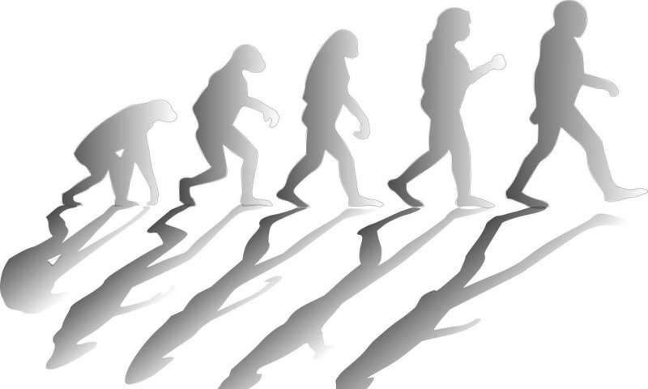

Name: ____________________________

Contents
Lesson Number and topic | Attendance

Teacher Comment: | Next Steps:
Student Comment:

Date:____________________________
Variation
L.O - To learn
Starter - Similarities and Differences
List the differences and similarities you can see between these two dogs.
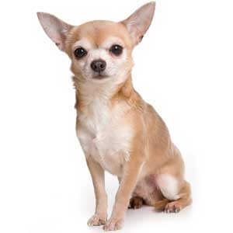
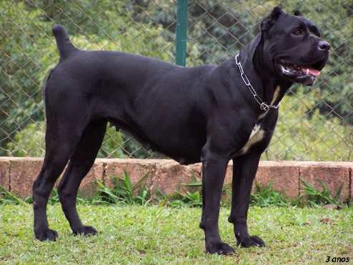

Reading
Every living organism is different in some ways, even those within the same species. These different characteristics among different individuals are called variations. Variations can be caused by two key factors: genetics and environment. There are some characteristics that are caused purely by genetic factors or environmental factors, but quite a lot are caused by a mix of both.
Type of Variation | Characteristic
Genetic Variation
Environmental Variation
Both types of variation

Here are some examples:
- Purely genetics: Gender, shape of earlobes, eye colour

- Purely environmental: It is rather rare that a variation is led purely by the environment. One possible example is scars, as they are formed only if you had an injury, although the “ability” to form scars is varied by genetics.

- Mix of both: Weight, height, skin colour, hair colour
These genetic and environmental variations can arise due to a variety of reasons. Here are some:
Genetic variations:
- Random mutation: DNA changes spontaneously that lead to a different allele (a different version of the same gene) that can give a different characteristic. Eg. Dominant allele for brown eyes mutated into a recessive allele for blue eyes

- Meiosis: The chromosomes from the father and mother may mix to exchange alleles. Also they may split up differently that leads to a different combination of alleles, which could give the child a different characteristic compared to his/her parents.
Environmental variations:
- Lifestyle: Diet and the amount of exercise could affect one’s physical appearance and fitness.
- Exposure to the sun: Change skin colour
- Dyeing your hair: Change hair colour
- Piercings
- Injuries: Lead to scar formation
Mutations happen all the time; mostly they have no effect on the organism. Sometimes they might influence the phenotype. Very rarely will they change the phenotype completely.

SLOP Questions
- What is variation?
_______________________________________________________________________________________________
_______________________________________________________________________________________________
_______________________________________________________________________________________________
- Genes determine the phenotype of an organism – true or false?
_______________________________________________________________________________________________
_______________________________________________________________________________________________
- Within a population, there is normally very little genetic variation – true or false?

_______________________________________________________________________________________________
- What are the two factors that cause variation?
_______________________________________________________________________________________________
_______________________________________________________________________________________________
- Sort whether the following factors are influenced by genes, environment or both:
a.) Height:__________________________________________________________________________

b.) Scars: ___________________________________________________________________________

c.) Eye colour:_______________________________________________________________________

d.) Hair colour:______________________________________________________________________

- Apart from the ones mentioned above, suggest one genetic factor and one influenced by both genes and environment that lead to variation.

- Genetic: ______________________________________________________________________________

- Both: ________________________________________________________________________________________
- How are identical twins ‘identical’ to one another?
_______________________________________________________________________________________________
_______________________________________________________________________________________________
_______________________________________________________________________________________________
- In a pair of identical twins, one is taller than the other. Suggest why.
_______________________________________________________________________________________________
_______________________________________________________________________________________________
_______________________________________________________________________________________________

Date:____________________________
The theory of evolution
L.O - To learn
Reading
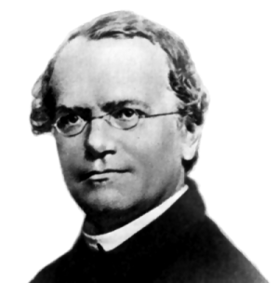
In the mid-19th century Gregor Mendel carried out breeding experiments on peas (smooth vs. wrinkled; green vs. yellow). One of his observations was that the inheritance of each characteristic is determined by ‘units’ that are passed on to descendants unchanged. People did not recognise how important Mendel’s discovery was, as they did not understand his theory due to lack of knowledge on genes and chromosomes.

In the late 19th century behaviour of chromosomes during cell division was observed. In the early 20th century it was observed that chromosomes and Mendel’s ‘units’ behaved in similar ways. This led to the idea that the ‘units’, now called genes, were located on chromosomes.

In the mid-20th century the structure of DNA was determined and the mechanism of gene function worked out. The double helix structure was found by Watson and Crick, using X-ray results from Franklin and Wilkins but without Franklin’s permission. This scientific work by many scientists led to the gene theory being developed.

SLOP Questions
- Name the person who first discovered inherited characteristics are determined by 'units'
_______________________________________________________________________________________________
_______________________________________________________________________________________________
_______________________________________________________________________________________________
- Why were Mendel's ideas of inheritance not accepted during his time?
_______________________________________________________________________________________________
_______________________________________________________________________________________________
_______________________________________________________________________________________________
- Who published the double helix structure of DNA?
_______________________________________________________________________________________________
_______________________________________________________________________________________________
_______________________________________________________________________________________________

- Watson and Crick used whose work to find out the structure of DNA?
_______________________________________________________________________________________________
_______________________________________________________________________________________________
_______________________________________________________________________________________________
- What is the name for the structure of DNA?
_______________________________________________________________________________________________
_______________________________________________________________________________________________
_______________________________________________________________________________________________
- Name the 4 bases in DNA
_______________________________________________________________________________________________
_______________________________________________________________________________________________
_______________________________________________________________________________________________
- How many bases code for an amino acid
_______________________________________________________________________________________________
_______________________________________________________________________________________________
_______________________________________________________________________________________________

Date:____________________________
Evolution by natural selection
L.O - To
Reading
Earth is about 4.5 billion years old and there is scientific evidence to suggest that life on Earth began more than three billion years ago. The idea behind the theory of evolution through the process of natural selection is that all species of living things have evolved from simple life forms over a period of time. Over time it appears that organisms have become more complex. This is due to evolution by natural selection.
Natural selection is the process where nature selects what characteristics (controlled by genes) are best for organisms to survival in that particular environment and hence allows it to reproduce.
In simple terms, this is the survival of the fittest, where “fittest” refers to those best adapted to their environment, but not necessarily the strongest. Evolution occurs after natural selection occurs over many generations. This is the process:
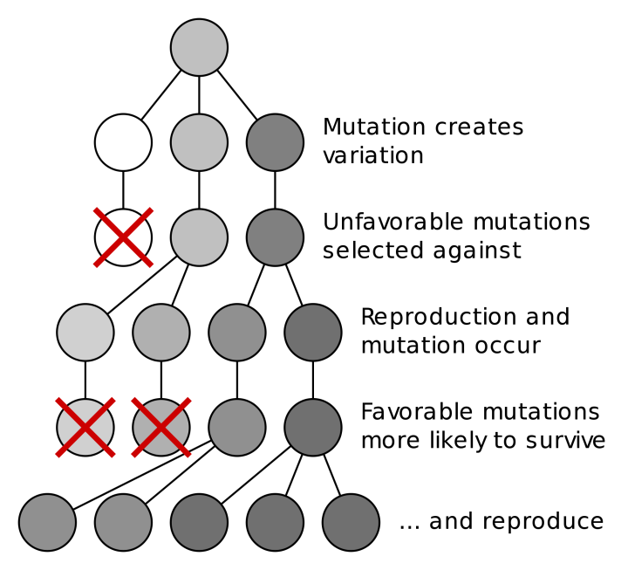
    - Individuals in a species show a wide range of variation and this variation is because of differences in their genes. due to random mutation.
    - Individuals with characteristics most suited to their environment are more likely to survive and breed successfully. (Those without the favourable characteristic are more likely to die before they could reproduce.)
    - The characteristics that have enabled these individuals to survive are then passes on to the next generation.
Both genes and the environment can cause variation, but only genetic variation can be passed on to the next generation.
Evolution must happen over many generations! And it is not by choice, but by natural selection.
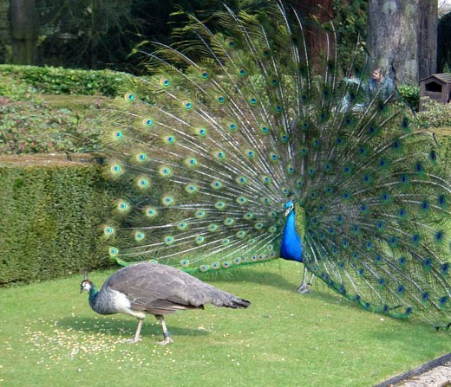
Example - A simple example can be seen in peacocks:
- females choose a mate based on their colourful tail feathers
- the more colourful the tail of a peacock, the more likely they are to mate and pass on these genes
- over time, the tails of peacocks have become more colourful

SLOP Questions
- What is variation?
_______________________________________________________________________________________________
_______________________________________________________________________________________________
_______________________________________________________________________________________________
- What causes genetic variation?
_______________________________________________________________________________________________
_______________________________________________________________________________________________
_______________________________________________________________________________________________
- What is a ‘species’?
_______________________________________________________________________________________________
_______________________________________________________________________________________________
_______________________________________________________________________________________________
- State the theory of evolution by natural selection.
_______________________________________________________________________________________________
_______________________________________________________________________________________________
_______________________________________________________________________________________________
- Describe the process of evolution by natural selection.
_______________________________________________________________________________________________
_______________________________________________________________________________________________
_______________________________________________________________________________________________
- Pick one of the following. Would the best organism within a species to survive and reproduce be:
- the strongest?
- the one which reproduces the fastest?
- the best adapted to the environment?

- Suggest how giraffes having long necks may be a result from evolution by natural

selection.
_______________________________________________________________________________________________
_______________________________________________________________________________________________
_______________________________________________________________________________________________
_______________________________________________________________________________________________
_______________________________________________________________________________________________
_______________________________________________________________________________________________
_______________________________________________________________________________________________

- In the beginning, there are more white peppered moths than black peppered moths

living on trees. However, during and after the Industrial Revolution period, the number of black peppered moths drastically increased. Explain in detail.

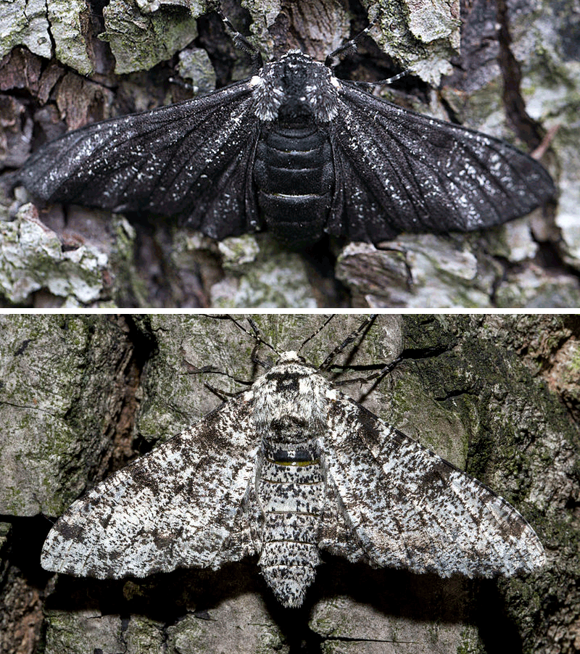
Keywords to use: Black soot, natural selection, reproduce, survive, characteristics, variation, time.

__________________________________________________
__________________________________________________
__________________________________________________
__________________________________________________
__________________________________________________
__________________________________________________
___________________________________________________________________________
___________________________________________________________________________
___________________________________________________________________________
___________________________________________________________________________
___________________________________________________________________________
___________________________________________________________________________
___________________________________________________________________________
___________________________________________________________________________
___________________________________________________________________________
___________________________________________________________________________
___________________________________________________________________________
___________________________________________________________________________
___________________________________________________________________________
___________________________________________________________________________
___________________________________________________________________________
___________________________________________________________________________
___________________________________________________________________________
___________________________________________________________________________
Date:____________________________
Theories of evolution + Accepting Darwin’s ideas
L.O - To learn
Reading
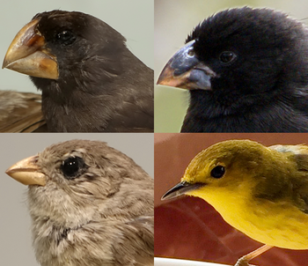
Charles Darwin, as a result of observations on a round-the-world expedition, backed by years of experimentation and discussion and linked to developing knowledge of geology and fossils, proposed the theory of evolution by natural selection.
• Individual organisms within a particular species show a wide range of variation for a characteristic.
• Individuals with characteristics most suited to the environment are more likely to survive and breed successfully.
• The characteristics that have enabled these individuals to survive are then passed on to the next generation.

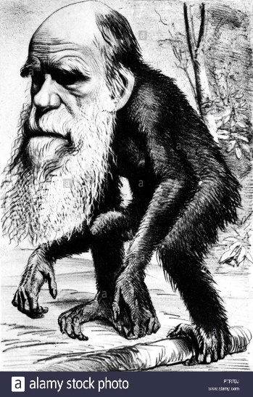
Darwin published his ideas in On the Origin of Species (1859). There was much controversy surrounding these revolutionary new ideas. The theory of evolution by natural selection was only gradually accepted because:
- People strongly believed that God made all animals and plants
on Earth.
- There was insufficient evidence at the time the theory was
published to convince many scientists
- People didn’t understand how characteristics are inherited. until
50 years after the theory was published.

Jean-Baptiste Lamarck
At the beginning of the 19th century Jean-Baptiste Lamarck was a French scientist who developed an alternative theory of evolution before Charles Darwin.
Lamarck's theory involved two ideas:
- A characteristic which is used more and more by an organism becomes bigger and stronger, and one that is not used eventually disappears.

- Any feature of an organism that is improved through use is passed to its offspring

However, through modern science we now know that in the vast majority of cases this type of inheritance cannot occur.
Lamarck's theory cannot account for all the observations made about life on Earth. For instance, his theory implies that all organisms would gradually become complex, and simple organisms disappear.
Lamarck's theory suggested that the giraffe's original short-necked ancestor repeatedly stretched its neck to reach the higher branches to eat. Lamarck believed that the stretching elongated the giraffe's neck, which became a useful characteristic and was passed onto future generations. This resulted in the length of the giraffe's neck increasing over time.
It is now commonly accepted that Lamarck's ideas were wrong. For example, simple organisms are still detected in all varieties of life, plus it is now known that mutations can create variation such as neck length.
SLOP Questions
- Name the person who proposed the theory of evolution.
____________________________________________________________________________

- Name the person who suggested changes that occur in an organism during its lifetime can be inherited.
____________________________________________________________________________

- What is Darwin's theory of evolution by natural selection?

_______________________________________________________________________________________________
_______________________________________________________________________________________________
_______________________________________________________________________________________________
_______________________________________________________________________________________________
_______________________________________________________________________________________________
_______________________________________________________________________________________________
- State three reasons why Darwin’s ideas were only slowly accepted.

_______________________________________________________________________________________________
_______________________________________________________________________________________________
_______________________________________________________________________________________________

- Evolution take a long time to happen so organisms do not normally change during a persons’ lifetime. Explain why this can make it difficult to ‘prove’ evolution is happening.

_______________________________________________________________________________________________
_______________________________________________________________________________________________
_______________________________________________________________________________________________

- In the 1800s, many scientists could not decide whether Lamarck’s theory or Darwin’s theory was the right one. Give two reasons why.

_______________________________________________________________________________________________
_______________________________________________________________________________________________
_______________________________________________________________________________________________

- Before the 1800s, many people had a different idea to explain where all the living things on Earth came from. What idea was this?

_______________________________________________________________________________________________
_______________________________________________________________________________________________
_______________________________________________________________________________________________

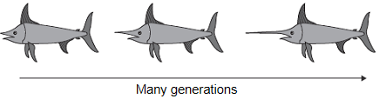
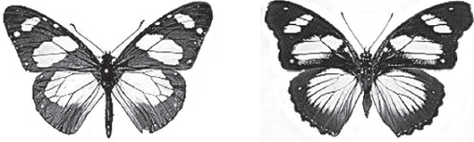
Amauris Hypolimnas
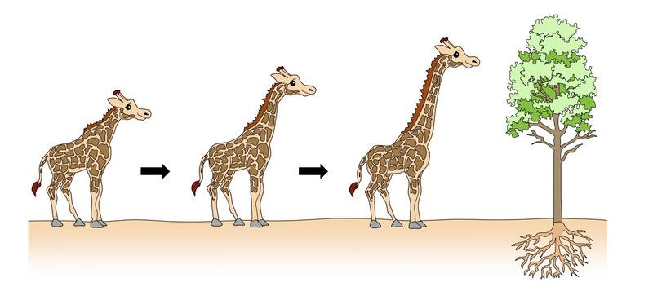
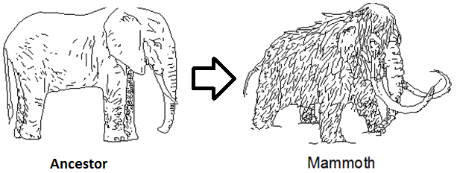
Ancestors of swordfish had short swords. Modern swordfish have long swords. Swordfish use their swords to injure prey
How would Lamarck explain the change in the length of the sword?
How would Darwin explain the change in length of the sword?
Woolly mammoths evolved from a much less hairy ancestor. Use Darwin’s theory of Natural Selection to explain how this happened
Giraffes have got very long necks, however, their ancestors did not.
How would Lamarck explain the change in the length of the Giraffes neck?
How would Darwin explain the change in length of the Giraffes neck?
Both species of butterfly can be eaten by most birds.
Amauris has an unpleasant taste which birds do not like, so birds have learned not to prey on it.
Hypolimnas does not have an unpleasant taste but most birds do not prey on it.

(a) Suggest why most birds do not prey on Hypolimnas. (2)
(b) Suggest an explanation, in terms of natural selection, for the markings on the wings of Hypolimnas. (3)

Date:____________________________
Speciation
L.O - To learn
Reading
Alfred Russel Wallace independently proposed the theory of evolution by natural selection. He published joint writings with Darwin in 1858 which prompted Darwin to publish On the Origin of Species (1859) the following year.

Wallace worked worldwide gathering evidence for evolutionary theory. He is best known for his work on warning colouration in animals and his theory of speciation.

Alfred Wallace did much pioneering work on speciation (how new species form) Wallace noticed that closely related species were separated by a geographical barrier such as a wide river, but more evidence over time has led to our current understanding of the theory of speciation.

What is a Species?

Process of speciation:
- Isolation occurs – when a species becomes separated into two populations
- Due to a Geographical barrier such as a new river/island/mountain being formed. This is caused by natural phenomenon (eg. earthquakes, volcanic eruption)
- Due to the Environment (eg. climate change)

Because of this no interbreeding can take place.

- Natural selection occurs:
- There is genetic variation within one species between individuals
- Alleles for characteristics favourable for survival and successful breeding in the new conditions will be selected
- Those with favourable alleles can survive and reproduce
pass on favourable alleles (genetic variation increases)
- Speciation occurs – eventually, the organisms change so much that they can no longer interbreed with the original organisms to produce fertile offspring
- Two new species have now formed.

Evolutionary trees
Evolutionary trees are used to represent the relationships between organisms. Branches show places where speciation has occurred, and a new species has evolved.
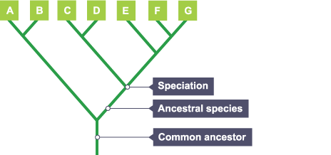
Evolutionary trees are used to represent the relationships between organisms. Branches show places where speciation has occurred, and a new species has evolved.
In this evolutionary tree, species A and B share a recent common ancestor. Species A is therefore most similar to species B.
Species F and G also share a recent, yet different, common ancestor, which itself shared a common ancestor with species E. All seven species share a common ancestor, probably from the distant past. The information is collected from a variety of sources, for example, fossil records and DNA sequences.
SLOP Questions
- Who worked with Darwin to develop the theory of evolution?
_______________________________________________________________________________________________
_______________________________________________________________________________________________
_______________________________________________________________________________________________
- Apart from evolution, what are two other studies Wallace worked on?
_______________________________________________________________________________________________
_______________________________________________________________________________________________
_______________________________________________________________________________________________
- What is speciation?
_______________________________________________________________________________________________
_______________________________________________________________________________________________
_______________________________________________________________________________________________
- What needs to happen to a population of species in order for speciation to occur?
_______________________________________________________________________________________________
_______________________________________________________________________________________________
- Give the six steps in the process of speciation.
_______________________________________________________________________________________________
_______________________________________________________________________________________________
_______________________________________________________________________________________________
_______________________________________________________________________________________________
_______________________________________________________________________________________________
_______________________________________________________________________________________________

The photographs show two species of gull.

Herring gull Lesser black-backed gull

(Larus argentatus) (Larus fuscus)

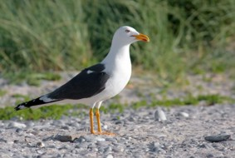
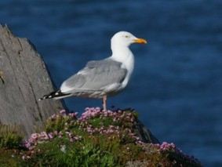

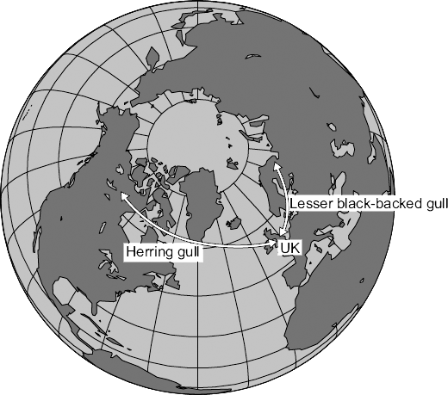
Both species are now found in the UK but the two species cannot interbreed with each other. Scientists believe that these two species have evolved from a common ancestor.

The map below shows a view of the Earth from above the North Pole.
The map also shows where these two species are found.
- Suggest an explanation for the development of these different species.

_______________________________________________________________________________________________
_______________________________________________________________________________________________
_______________________________________________________________________________________________
_______________________________________________________________________________________________
_______________________________________________________________________________________________
___________________________________________________________________________
_______________________________________________________________________________________________
_______________________________________________________________________________________________
_______________________________________________________________________________________________
_______________________________________________________________________________________________
- The illustration below shows two types of pistol shrimp.

The shrimps live in shallow, tropical seas on opposite sides of Panama.

Panama

Not to scale
- Scientists put one Type A shrimp and one Type B shrimp together in a tank of seawater. The two types of shrimp snapped their claws aggressively at each other. They did not mate.

The scientists said that this was evidence for the Type A and Type B shrimps being classified as two different species.
- Give one reason why the scientists’ opinion may be correct.
_______________________________________________________________________________________________
_______________________________________________________________________________________________
_______________________________________________________________________________________________
- Suggest two reasons why the scientists’ opinion may not be correct.
_______________________________________________________________________________________________
_______________________________________________________________________________________________
_______________________________________________________________________________________________

(c) Panama is a narrow strip of land which today joins North America and South America. It was formed by land moving up from beneath the sea. Panama has separated the Pacific Ocean and the Caribbean Sea for the past 3 million years.

Explain how two different species of pistol shrimp could have developed from an ancestral species of shrimp.
_______________________________________________________________________________________________
_______________________________________________________________________________________________
_______________________________________________________________________________________________
_______________________________________________________________________________________________
_______________________________________________________________________________________________

_______________________________________________________________________________________________

- Darwin’s theory of evolution states that all species of living things have evolved from simple life forms.

Darwin’s theory was published in 1859.
  - Give two reasons why Darwin’s theory was only slowly accepted.
_______________________________________________________________________________________________
_______________________________________________________________________________________________
_______________________________________________________________________________________________

(b) Darwin observed birds called finches on the Galapagos Islands, 1000 km from the coast of South America. He saw that the birds were similar to, but not the same as, birds he had seen on the mainland of South America. Recent evidence suggests that 13 different species of finch on the islands evolved from 1 species of finch that arrived from the mainland about 1 million years ago.

The diagram below shows the evolutionary tree for some Galapagos finches.

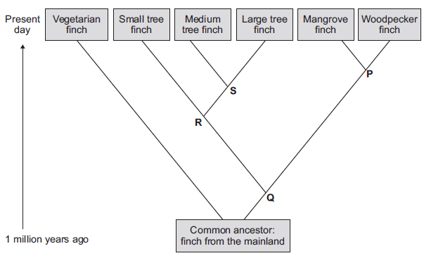
- Which type of present-day finch is least closely related to all the others?
_______________________________________________________________________________________________
_______________________________________________________________________________________________
- Which branching point, P, Q, R or S, on the diagram above shows the most recent common ancestor of all the tree finches?
_______________________________________________________________________________________________
_______________________________________________________________________________________________
_______________________________________________________________________________________________
- Which two finches have the most recent common ancestor?
_______________________________________________________________________________________________
_______________________________________________________________________________________________
Date:____________________________
Fossils
L.O - To learn
Reading
The process of evolution is only a theory. It needs to be supported by evidence – fossils.

Fossils are the remains of organisms from millions of years ago found in rocks or ice.

Through looking at fossil records, we can see how organisms are structurally adapted in the past. It also helps scientists to understand how they have changed since life developed on Earth, which can act as evidence for evolution by natural selection.

There are different forms of fossils, depending on how they are formed. A lack of decay is key to forming fossils. There are a few factors needed for decay:
- Bacteria (as decomposers – the nutrients inside organisms are their food source and raw material for respiration)
- Oxygen (for aerobic respiration of bacteria)
- Correct temperature (too hot – enzymes in bacteria denature, leading to their death; too cold – enzymes are inactive, leading to a lack of respiration)
It is nearly impossible to have no bacteria in the environment; hence the environment must be lacking in oxygen and/or at a wrong temperature in order for fossilisation to occur.

Fossils may be formed in the followings ways. For example:
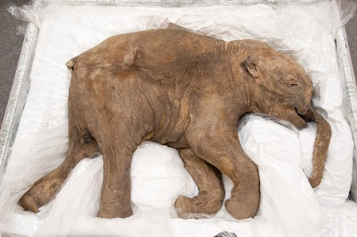
- Parts of organisms that have not decayed because one or more of the conditions needed for decomposition are absent. For example, dead animals and plants can be preserved in amber, peat bogs, tar pits, or in ice.
Eg. A whole baby mammoth (with muscles, blood, fur intact) was found frozen in ice

- Hard body parts, such as bones and shells, which do not decay easily or are replaced by minerals as they decompose.

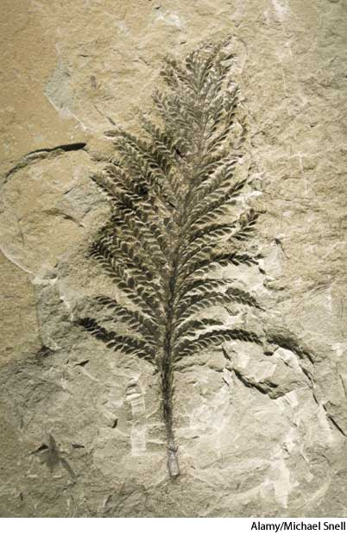
- Preserved traces of organisms, such as footprints, burrows and rootlet traces - these become covered by layers of sediment, which eventually become rock.

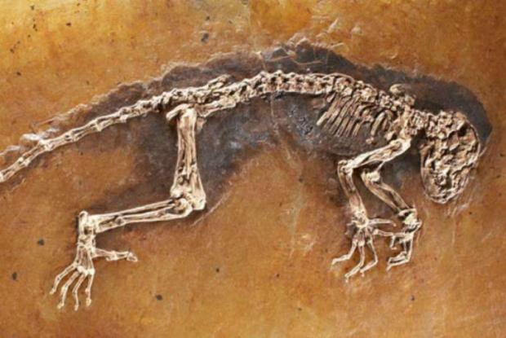
Process of fossilisation of skeletons
- Organism dies and falls to the ground
- Soft parts (eg. Flesh) decompose, leaving the bones behind as they are harder to decay
- The skeleton is then covered in sand/soil
- The skeleton becomes mineralised (bone tissue replaced by mineral ions) over millions of years turns to rock
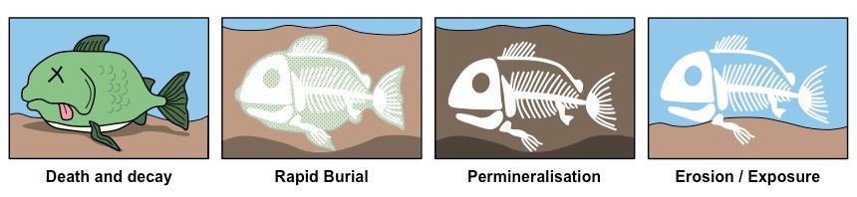
It is important to remember that bone tissues can still decay as they are organic, but just takes a longer time to do so. If they get replaced by the minerals before they decay, meaning the minerals can form a mould of their shapes, then the fossil can be made.

Even though fossils are a great way to support the theory of evolution, it is not enough as we do not have a complete fossil record. The reasons for this are as follows:
- Many early life forms are soft-bodied (no shell or skeleton), which means they decay quickly and cannot be mineralised to form fossils

- Geological activity destroyed some fossils, such as earthquakes

- Most organisms did not become fossilised – the conditions for fossilisation are very rare, and any imprints made are washed away easily.

This is why scientists cannot be certain how life on Earth began

SLOP Questions
- What are fossils?
_______________________________________________________________________________________________
_______________________________________________________________________________________________
_______________________________________________________________________________________________

- What are the three criteria for decay to occur?
_______________________________________________________________________________________________
_______________________________________________________________________________________________
_______________________________________________________________________________________________

- Describe the five steps of fossilisation by mineralisation.
_______________________________________________________________________________________________
_______________________________________________________________________________________________
_______________________________________________________________________________________________
_______________________________________________________________________________________________
_______________________________________________________________________________________________

_______________________________________________________________________________________________

- Why is it harder for bones to decay?
_______________________________________________________________________________________________
_______________________________________________________________________________________________
_______________________________________________________________________________________________

- What are the three different types of fossils that can be formed?
_______________________________________________________________________________________________
_______________________________________________________________________________________________
_______________________________________________________________________________________________

- Fossils which are older often appear to be simpler organisms. What theory does this provide evidence to support?
_______________________________________________________________________________________________
_______________________________________________________________________________________________
_______________________________________________________________________________________________

Date:____________________________
Extinction
L.O - To learn
Reading
What is extinction?

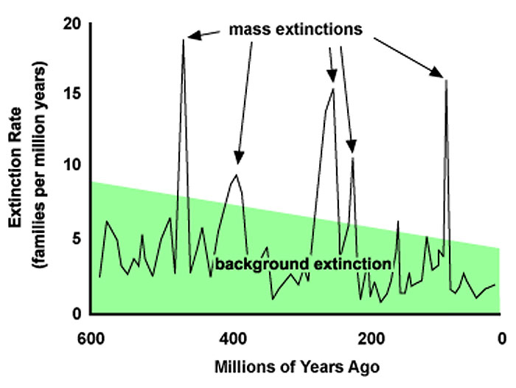
Mass extinction, on the other hand, is the loss of many or most species on Earth, and it usually happens over several million years. So far, there have been five mass extinction events, as seen on the five major peaks in the graph.
Extinctions can be caused by different factors.

Biotic (living) causes of extinction
- New predators – organisms could not adapt quickly enough to survive the new predators and were all killed before they could reproduce and pass on favourable alleles
- Successful interspecific competition – the species that got outcompeted for food, territory/shelter etc. may become extinct overtime
- New diseases/pathogens – if the majority of the species could not (adapt to) survive the new disease then they may become extinct
Abiotic (non-living) causes of extinction
- Climate change
- Single catastrophic event – eg. volcanic eruption, asteroid collision- Often link to climate change!

A single catastrophic event is perhaps the more common cause of mass extinction. The dinosaurs are believed to become extinct during one of the mass extinction events. One of the most supported theories is that an asteroid collision triggered it. The collision alone may kill many dinosaurs, but how may it caused them to become extinct (which usually requires a longer time)?
- Asteroid collision caused tectonic plates to shift
- This triggered earthquakes and tsunamis, which then subsequently triggered volcanic eruptions
- The lava itself could kill many organisms already. On top of that, the eruption(s) could produce a massive ash cloud which may cover a large portion (if not all) of the earth
The ash cloud blocked out sunlight, preventing them from reaching the surface. This could then have two effects:
- Plants (producers) don’t get sunlight and cannot do photosynthesis. They then die out, which then affects the food chain

- Global temperature drops, eventually leading to the ice age

SLOP Questions
- How is the fossil record helpful?
_______________________________________________________________________________________________
_______________________________________________________________________________________________
_______________________________________________________________________________________________

- Define 'extinction'
______________________________________________________________________________________________
_______________________________________________________________________________________________
_______________________________________________________________________________________________

- State three causes of extinction.
_______________________________________________________________________________________________
_______________________________________________________________________________________________
_______________________________________________________________________________________________

- What causes mass extinction? Suggest two examples of this cause.
_______________________________________________________________________________________________
_______________________________________________________________________________________________
_______________________________________________________________________________________________

- What is the difference between extinction and mass extinction?
_______________________________________________________________________________________________
_______________________________________________________________________________________________
_______________________________________________________________________________________________

- Suggest a chain of events initiated by an asteroid collision that could lead to the extinction of dinosaurs.
_______________________________________________________________________________________________
_______________________________________________________________________________________________
_______________________________________________________________________________________________

- Fossils give evidence about organisms that lived a long time ago.
  - Scientists have found very few fossils of the earliest life forms. Give one reason why.
_______________________________________________________________________________________________
_______________________________________________________________________________________________
_______________________________________________________________________________________________

This is a photograph of a fossilised fish.
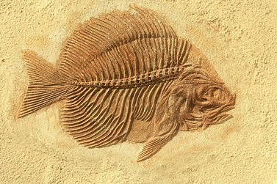

- Suggest how the fossil in the photograph above was formed.
_______________________________________________________________________________________________
_______________________________________________________________________________________________
_______________________________________________________________________________________________

_______________________________________________________________________________________________
_______________________________________________________________________________________________

The species of fish shown in the photograph above is now extinct.
- Give two possible causes of extinction.
_______________________________________________________________________________________________
_______________________________________________________________________________________________
Date:____________________________
Selective breeding
L.O - To learn
Reading
Humans can speed up evolution by doing selective breeding (artificial selection).
It is the process by which humans breed plants and animals for desired characteristics.

Here is a list of desired characteristics (and quite often the advantages to selective breeding):

- Disease resistance in crops
- Animals which produce more milk or more meat
- Gentle nature of domestic animals (eg. Dogs)
- Large or unusual flowers.

It is especially useful in agriculture, where farmers want all or most of their animals or plants to be resistant to diseases and can grow in size quickly, so they could farm and harvest as efficiently as possible for profit. This is the process of selective breeding:

- Choose two individuals with the desired characteristic(s) from a mixed population.

- Allow them to breed, which produces offspring with a range of characteristics.

- Choose the few offspring with the (most) desired trait(s) and allow them to breed.

- Repeat this cross-breeding process over many generations until all the offspring show the desired characteristic.
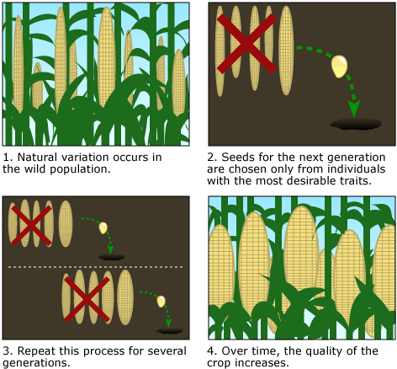

There are pros and cons to selective breeding.

Advantages | Disadvantages
Disease resistance in food crops | Reduces genetic variation (lose allele variation) less likely to be able to cope with major environmental changes die out
Animals which produce more meat or milk | Inbreeding more prone to certain diseases/inherited conditions  (more likely to inherit homozygous recessive alleles recessive genetic disorders)
Domestic dogs with a gentle nature

Large or unusual flowers

SLOP Questions
- Define ‘selective breeding’
_______________________________________________________________________________________________
_______________________________________________________________________________________________
_______________________________________________________________________________________________

- What are the desired characteristics in farm animals? Explain.
______________________________________________________________________________________________
_______________________________________________________________________________________________
_______________________________________________________________________________________________

- Describe the process of selective breeding.
_______________________________________________________________________________________________
_______________________________________________________________________________________________
_______________________________________________________________________________________________

- Name two historic examples of selective breeding.
_______________________________________________________________________________________________
_______________________________________________________________________________________________
_______________________________________________________________________________________________

- State four modern examples of selective breeding.
_______________________________________________________________________________________________
_______________________________________________________________________________________________
_______________________________________________________________________________________________

- How do breeders of domestic pets use selective breeding to produce many pets?
______________________________________________________________________________________________
_______________________________________________________________________________________________
_______________________________________________________________________________________________

- Give two desirable characteristics in crops
_______________________________________________________________________________________________
_______________________________________________________________________________________________
_______________________________________________________________________________________________

- Explain how selective breeding reduces genetic variation.
_______________________________________________________________________________________________
_______________________________________________________________________________________________
_______________________________________________________________________________________________

- Give Explain how selective breeding can lead to extinction of a species.
_______________________________________________________________________________________________
_______________________________________________________________________________________________
_______________________________________________________________________________________________

- Explain how selective breeding reduces genetic variation.
_______________________________________________________________________________________________
_______________________________________________________________________________________________
_______________________________________________________________________________________________

Date:____________________________
Cloning
Reading
A clone is an individual that has been produced through asexual reproduction and is genetically identical to the parent. Clones can be made by different methods, also dependent on if you are trying to clone plants or animals.

Plant cloning
Plant cuttings – Take a cutting from the parent plant and place it in rooting powerder (contains plant hormones) to encourage the plant to develop root. This is small scale
Tissue culture: hundreads of clones
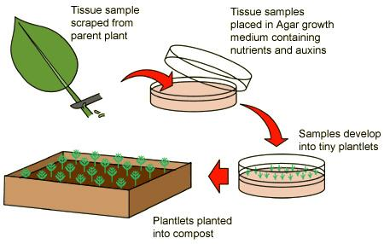
  - Take a parent plant and divide it into hundreds of tiny pieces (plant tissue)

  - The plant tissue is placed in growth medium with nutrients and plant hormones (eg. Auxins)

  - It eventually grows into plantlets

  - Plantlets are transferred to be planted in compost
- Conditions must be sterile. Its quick and cheap

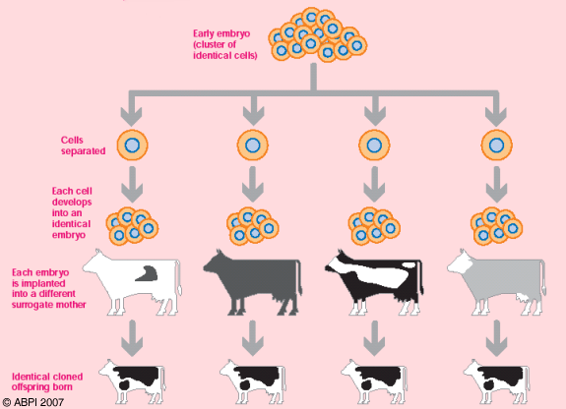
Animal cloning
Method 1 – Embryo Transplants

  - Sperm and egg with the desired characteristics are collected and a fertilised egg is produced.

  - Fertilised egg develops into an embryo before it becomes specialised.

  - Split the embryo into two.

  - Transfer these embryos into host mothers and allow them to grow naturally into fetuses

  - The cloned offspring are born and are genetically identical to each other, but not related to their host mothers. Because you are using an egg and sperm cells then you cannot be certain the offspring will have the characteristics you desire.
Method 2 – Adult cell cloning:

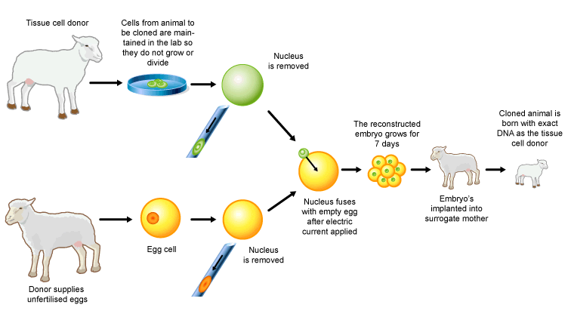
  - Extract an adult body cell and an unfertilised egg cell (from different individuals)

  - Remove the nucleus in the egg cell

  - Extract the nucleus from the adult body cell and insert it into the empty egg cell

  - Pass a small electric shock through to the egg cell, stimulating it to start dividing to form an embryo

  - Insert the embryo into an adult female to continue its development into a fetus

  - The offspring is genetically identical to the nucleus donor (ie. The donor of the adult body cell)

Some pros and cons of cloning:

Advantages | Disadvantages
Combine with genetic engineering to increase crop yield | Reduce genetic variety/Smaller gene pool → less likely to survive in changing environment
Save animals from extinction | Potential use in engineering human babies (ethical concerns)

SLOP Questions
- Define ‘clone’.
_______________________________________________________________________________________________
_______________________________________________________________________________________________
_______________________________________________________________________________________________

- Name the traditional method of artificial plant cloning
______________________________________________________________________________________________
_______________________________________________________________________________________________
_______________________________________________________________________________________________

- Name the modern method of artificial plant cloning
_______________________________________________________________________________________________
_______________________________________________________________________________________________

- What are “plant cuttings”?
_______________________________________________________________________________________________
_______________________________________________________________________________________________

- Describe the process of modern artificial plant cloning.
_______________________________________________________________________________________________
_______________________________________________________________________________________________
_______________________________________________________________________________________________

- Compare the offspring from embryo transplants with each other and with the parents.
______________________________________________________________________________________________
_______________________________________________________________________________________________
_______________________________________________________________________________________________

- Explain why artificial plant cloning is useful.
_______________________________________________________________________________________________
_______________________________________________________________________________________________
_______________________________________________________________________________________________

- Describe in detail how adult cell cloning is done.
_______________________________________________________________________________________________
_______________________________________________________________________________________________
_______________________________________________________________________________________________

- Compare the offspring in adult cell cloning to both its parents.
_______________________________________________________________________________________________
_______________________________________________________________________________________________
_______________________________________________________________________________________________

- Compare the offspring in adult cell cloning to both its parents.
_______________________________________________________________________________________________
_______________________________________________________________________________________________
_______________________________________________________________________________________________

