Westfield Science Department

2.Bonding & Structure Mastery Booklet
(Chemistry Paper 1)
Name : ______________________
Teacher : ____________________
Date Given : __________________
These booklets are a consolidation of your learning. They should be used in the following way – You should attempt the questions WITHOUT looking at the answers. Then mark your questions with red pen and add any missing marks you missed.
THESE BOOKLETS WILL IMPROVE YOUR GRADES…!!

Q1.
This question is about fluorine.
(a) Figure 1 shows the arrangement of electrons in a fluorine atom.
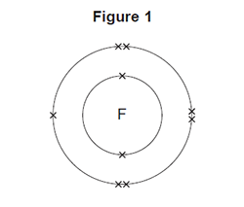
(i) In which group of the periodic table is fluorine?
Group _______________________________
(1)
(ii) Complete the table below to show the particles in an atom and their relative masses.

Name of particle | Relative mass
Proton
Neutron | 1
 | Very small
(2)
(iii) Use the correct answer from the box to complete the sentence.

alkalis | alloys | isotopes
Atoms of fluorine with different numbers of neutrons are
called ________________ .
(1)
(b) Sodium reacts with fluorine to produce sodium fluoride.
(i) Complete the word equation for this reaction.
sodium + ___________________ → ____________________
(1)
(ii) Complete the sentence.
Substances in which atoms of two or more different elements are chemically
combined are called _____________________ .
(1)
(iii) The relative formula mass (M_{r}) of sodium fluoride is 42.
Use the correct answer from the box to complete the sentence.

ion | mole | molecule
The relative formula mass (M_{r}), in grams, of sodium fluoride is one
_______________ of the substance.
(1)
(iv) Figure 2 shows what happens to the electrons in the outer shells when a sodium atom reacts with a fluorine atom.
The dots (•) and crosses (×) represent electrons.
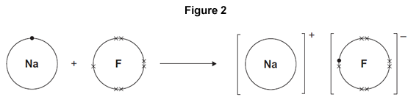
Use Figure 2 to help you answer this question.
Describe, as fully as you can, what happens when sodium reacts with fluorine to produce sodium fluoride.
______________________________________________________________
______________________________________________________________
______________________________________________________________
______________________________________________________________
______________________________________________________________
______________________________________________________________
______________________________________________________________
______________________________________________________________
(4)

(v) Sodium fluoride is an ionic substance.
What are two properties of ionic substances?

Tick (✔) two boxes.
Dissolve in water
Gas at room temperature
High melting point
Low boiling point
(2)
(Total 13 marks)
Q2.
This question is about magnesium.
(a) (i) The electronic structure of a magnesium atom is shown below.
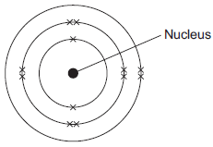
Use the correct answer from the box to complete each sentence.

electrons | neutrons | protons | shells
The nucleus contains protons and ____________________ .
The particles with the smallest relative mass that move around the nucleus are
called ____________________ .
Atoms of magnesium are neutral because they contain the same number of
electrons and ____________________ .
(3)

(ii) A magnesium atom reacts to produce a magnesium ion.
Which diagram shows a magnesium ion?
Tick () one box.
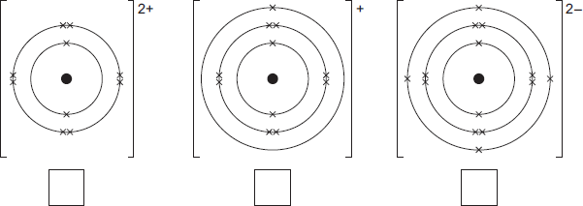
(1)
(b) Magnesium and dilute hydrochloric acid react to produce magnesium chloride solution and hydrogen.
Mg(s) + 2 HCl(aq) MgCl₂(aq) + H₂(g)
(i) State two observations that could be made during the reaction.
1. ____________________________________________________________
______________________________________________________________
2. ____________________________________________________________
______________________________________________________________
(2)
(ii) In this question you will be assessed on using good English, organising information clearly and using specialist terms where appropriate.
Describe a method for making pure crystals of magnesium chloride from magnesium and dilute hydrochloric acid.
In your method you should name the apparatus you will use.
You do not need to mention safety.
______________________________________________________________
______________________________________________________________
______________________________________________________________
______________________________________________________________
______________________________________________________________
______________________________________________________________
______________________________________________________________
______________________________________________________________
______________________________________________________________
______________________________________________________________
(6)
(Total 12 marks)
Q3.
Distress flares are used to attract attention in an emergency.
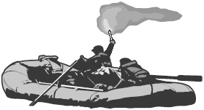
Flares often contain magnesium. Magnesium burns to form magnesium oxide.
(a) The distress flare burns with a bright flame because the reaction is very exothermic.
Complete the following sentence using the correct words from the box.

gives out heat stores heat takes in heat
An exothermic reaction is one which ____________________________________ .
(1)
(b) The diagram shows the electronic structure of a magnesium atom.
The atomic (proton) number of magnesium is 12.
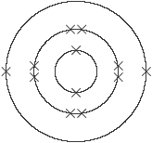
Magnesium atom
The atomic (proton) number of oxygen is 8.
Which diagram, A, B, C or D, shows the electronic structure of an oxygen atom?
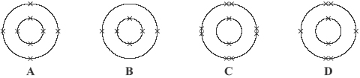
Diagram _______________
(1)
(c) Magnesium ions and oxide ions are formed when magnesium reacts with oxygen. The diagram shows the electronic structure of an oxide ion.
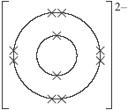
Oxide ion
Which diagram, J, K, L or M, shows the electronic structure of a magnesium ion?
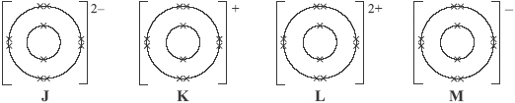
Diagram _______________
(1)
(d) Indigestion tablets can be made from magnesium oxide. The magnesium oxide neutralises some of the hydrochloric acid in the stomach.
Draw a ring around the name of the salt formed when magnesium oxide reacts with hydrochloric acid.
magnesium chloride magnesium hydroxide magnesium sulfate
(1)
(Total 4 marks)

Q4.
The structures of four substances, A, B, C and D, are represented in Figure 1.
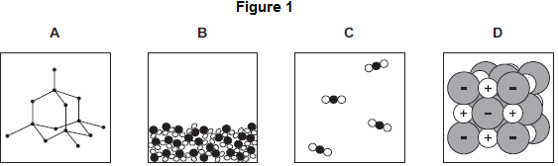
(a) Use the correct letter, A, B, C or D, to answer each question.

(i) | Which substance is a gas?
(1)

(ii) | Which substance is a liquid?
(1)

(iii) | Which substance is an element?
(1)

(iv) | Which substance is made of ions?
(1)
(b) Figure 2 shows the bonding in substance C.
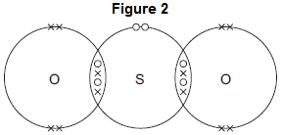
(i) What is the formula of substance C?
Draw a ring around the correct answer.

SO₂ | SO² | S₂O
(1)
(ii) Use the correct answer from the box to complete the sentence.

delocalised | shared | transferred
When a sulfur atom and an oxygen atom bond to produce substance C,
electrons are _____________________________________________
(1)
(iii) What is the type of bonding in substance C?
Draw a ring around the correct answer.

covalent | ionic | metallic
(1)
(Total 7 marks)
Q5.
The diagram represents a particle of methane.
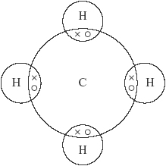
(a) What is the formula of methane? ________________________________________
(1)
(b) Choose a word from the box to answer the question.

atom ion molecule
Which of the words best describes the methane particle shown in the diagram?
_________________________
(1)
(c) Choose a word from the box to answer the question.

covalent ionic metallic
What is the type of bonding shown in the diagram?
_________________________
(1)
(Total 3 marks)
Q6.
A drill bit is used to cut holes through materials. The cutting end of this drill bit is covered with very small diamonds.
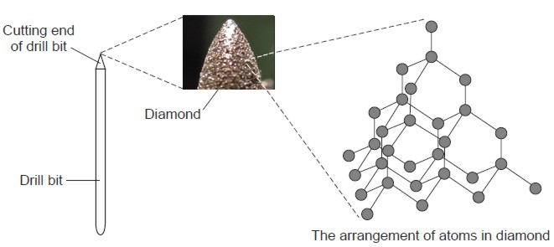
By Wanderlinse [CC By 2.0], via Flickr
Draw a ring around the correct word in each box.

 |  | carbon
(a) | Diamond is made from | nitrogen | atoms.
 |  | oxygen
(1)
 |  | none
(b) | Diamond has a giant structure in which | some | of the atoms are joined together.
 |  | all
(1)
 |  | covalent
(c) | The atoms in diamond are joined together by | ionic | bonds.
 |  | metallic
(1)
 |  | two
(d) | In diamond each atom is joined to | three | other atoms.
 |  | four
(1)

 |  | hard.
(e) | Diamond is suitable for the cutting end of a drill bit because it is | shiny.
 |  | soft
(1)
(Total 5 marks)
Q7.
This barbecue burns propane gas.
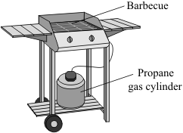
The diagram represents a propane molecule.
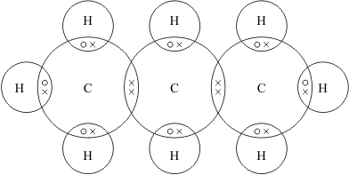
(a) What is the formula of propane?
_________________________________________
(1)
(b) (i) Draw a ring around the name of the particle represented by the symbols ○ and × in the diagram.
electron neutron proton
(1)
(ii) Draw a ring around the type of bonding that holds the atoms together in a propane molecule.
covalent ionic metallic
(1)

(c) Under high pressure in the cylinder propane is a liquid.
Liquid propane evaporates easily to form a gas when the tap on the cylinder is opened.
Draw a ring around the correct answer in each box to explain why propane evaporates easily.

Propane has a | high  low | boiling point because it consists of | large  small | molecules.
(1)
(Total 4 marks)
Q8.
Read the article and then answer the questions that follow.

Nanotennis!
Tennis balls contain air under pressure, which gives them their bounce. Normal tennis balls are changed at regular intervals during tennis matches because they slowly lose some of the air. This means that a large number of balls are needed for a tennis tournament, using up a lot of materials.
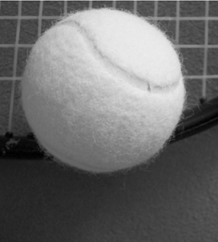
‘Nanocoated’ tennis balls have a ‘nanosize’ layer of butyl rubber. This layer slows down the escape of air so that the ball does not lose its pressure as quickly. The ‘nanocoated’ tennis balls last much longer and do not need to be replaced as often.
(a) How does the ‘nanosize’ layer make the tennis balls last longer?
___________________________________________________________________
___________________________________________________________________
(1)

(b) Put a tick () next to the best description of a ‘nanosize’ layer.

Description | ()
A layer one atom thick.
A layer a few hundred atoms thick.
A layer millions of atoms thick.
(1)
(c) Suggest why using ‘nanocoated’ tennis balls would be good for the environment.
___________________________________________________________________
___________________________________________________________________
___________________________________________________________________
___________________________________________________________________
___________________________________________________________________
(2)
(Total 4 marks)
Q9.
Glass is made from silicon dioxide.
© Velirina/iStock/Thinkstock
(a) Silicon dioxide has a very high melting point.
Other substances are added to silicon dioxide to make glass. Glass melts at a lower temperature than silicon dioxide.
Suggest why.
___________________________________________________________________
___________________________________________________________________
(1)
(b) Sodium oxide is one of the substances added to silicon dioxide to make glass.
(i) Sodium oxide contains Na⁺ ions and O^{2–} ions.
Give the formula of sodium oxide.
______________________________________________________________
(1)
(ii) Sodium oxide is made by heating sodium metal in oxygen gas.
Complete the diagram to show the outer electrons in an oxygen molecule (O₂).
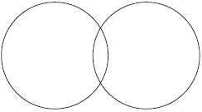
(2)
(c) Glass can be coloured using tiny particles of gold. Gold is a metal.
Describe the structure of a metal.
___________________________________________________________________
___________________________________________________________________
___________________________________________________________________
___________________________________________________________________
___________________________________________________________________
___________________________________________________________________
(3)
(Total 7 marks)
Q10.
Iron is the main structural metal used in the world.
(a) The diagram represents the particles in iron, Fe.

Draw a ring around the correct word in the box to complete the sentence.

Iron is described as an element because all the | atoms  compounds  metals | are the same.
(1)
(b) Stainless steel is mostly iron.
The diagram represents the particles in stainless steel.
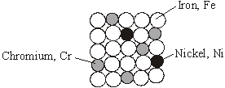
Use the correct words from the box to complete the sentences about alloys.

metal mixture molecule polymer smart structure
Stainless steel is an alloy because it is a __________________________________ of iron, chromium and nickel.
An alloy is made up of more than one type of _____________________________ .
Stainless steel alloys are harder than iron because the different sized atoms added
change the ________________________________________ .
An alloy that can return to its original shape after being deformed is called a
___________________________________ alloy.
(4)
(c) In the UK, we use about 1.8 billion steel cans every year but only 25% are recycled.
Used steel cans are worth about £100 per tonne.
Recycling saves raw materials and reduces waste that would end up in landfill. Producing steel by recycling used cans saves 75% of the energy that would be needed to produce steel from iron ore. This also reduces carbon dioxide emissions.
(i) Give two reasons, from the information above, to explain why recycling used steel cans is a good idea.
1. ____________________________________________________________
______________________________________________________________
2. ____________________________________________________________
______________________________________________________________
(2)
(ii) Suggest how the local council could increase the percentage of used steel cans that are recycled.
______________________________________________________________
______________________________________________________________
(1)
(Total 8 marks)
Q11.
The picture shows a wooden bowl.
The pieces of wood used for this bowl were dyed different colours.
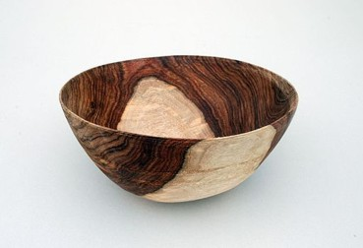
By Bertramz (Own work) [CC-BY-SA-3.0], via Wikimedia Commons
The artist who made the bowl explained why he dissolved the coloured dyes in methanol.

I use different coloured dyes dissolved in methanol.
I use methanol because with dyes dissolved in water the wood needs to be soaked for a longer time.
The bowl dries more quickly if I use methanol instead of water.
(a) The artist uses methanol instead of water.
Give two reasons why.
1. _________________________________________________________________
___________________________________________________________________
2. _________________________________________________________________
___________________________________________________________________
(2)

(b) The diagram shows how the atoms are bonded in methanol.
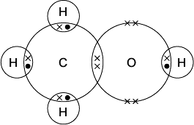
Draw a ring around:
(i) the formula of methanol

CH₄O | CH⁴O | CHO₄
(1)
(ii) the type of bonding in methanol.

covalent | ionic | metallic
(1)
(c) Methanol has a low boiling point.
Tick () the reason why.

Reason why | Tick ()
It has a giant covalent structure.
It is made of small molecules.
It has a giant metallic structure.
(1)
(Total 5 marks)

Q12.
Silicon dioxide is used as a lining for furnaces.
Furnaces can be used to melt iron for recycling.
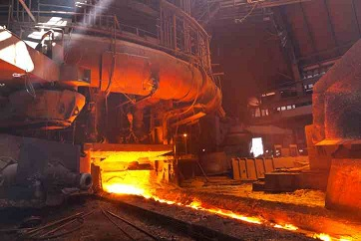
© Oleksiy Mark/iStock
The diagram shows a small part of the structure of silicon dioxide.
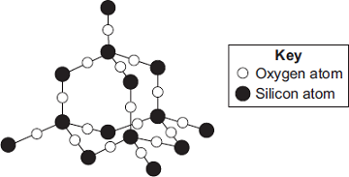
Explain why silicon dioxide is a suitable material for lining furnaces.
_______________________________________________________________________
_______________________________________________________________________
_______________________________________________________________________
_______________________________________________________________________
_______________________________________________________________________
_______________________________________________________________________
_______________________________________________________________________
_______________________________________________________________________
(Total 4 marks)

Q13.
This question is about the properties and uses of materials.
Use your knowledge of structure and bonding to answer the questions.
(a) Explain how copper conducts electricity.
___________________________________________________________________
___________________________________________________________________
___________________________________________________________________
___________________________________________________________________
___________________________________________________________________
(2)
(b) Explain why diamond is hard.
___________________________________________________________________
___________________________________________________________________
___________________________________________________________________
___________________________________________________________________
___________________________________________________________________
(2)
(c) Explain why thermosetting polymers are better than thermosoftening polymers for saucepan handles.
___________________________________________________________________
___________________________________________________________________
___________________________________________________________________
___________________________________________________________________
___________________________________________________________________
(2)
(Total 6 marks)

Q14.
The article gives some information about graphene.

Nanotunes!
Carbon can be made into nano-thin, strong sheets called graphene.
A graphene sheet is a single layer of graphite.
Graphene conducts electricity and is used in loudspeakers.
The picture shows the structure of graphene.
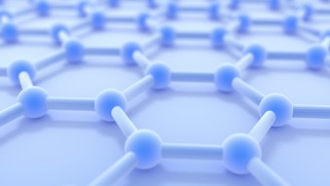
© 7immy/iStock
(a) Use the picture and your knowledge of bonding in graphite to:
(i) explain why graphene is strong;
______________________________________________________________
______________________________________________________________
______________________________________________________________
______________________________________________________________
______________________________________________________________
______________________________________________________________
(3)
(ii) explain why graphene can conduct electricity.
______________________________________________________________
______________________________________________________________
______________________________________________________________
______________________________________________________________
______________________________________________________________
______________________________________________________________
(2)
(b) Graphite is made up of layers of graphene.
Explain why graphite is a lubricant.
___________________________________________________________________
___________________________________________________________________
___________________________________________________________________
___________________________________________________________________
(2)
(Total 7 marks)

Mark schemes
Q1.
(a) (i) 7 / seven
1
(ii) 1
do not accept –1
1
Electron
1
(iii) isotopes
1
(b) (i) (sodium + ) fluorine → sodium fluoride
1
(ii) compounds
1
(iii) mole
1
(iv) sodium (atom) loses
1
fluorine (atom) gains
1
one electron
1
ions formed
1
allow sodium forms positive (ion) or fluorine forms negative (ion)
allow form ionic bond
allow to gain a full outer shell of electrons
allow forms noble gas structure
max 3 if reference to incorrect particle / bonding
(v) Dissolve in water
1
High melting point
1
[13]
Q2.
(a) (i) neutrons
this order only
1
electrons
1
protons
1
(ii) box on the left ticked
1
(b) (i) effervescence / bubbling / fizzing / bubbles of gas
do not accept just gas alone
1
magnesium gets smaller / disappears
allow magnesium dissolves
allow gets hotter or steam produced
ignore references to magnesium moving and floating / sinking and incorrectly named gases.
1
(ii) Marks awarded for this answer will be determined by the Quality of Communication (QC) as well as the standard of the scientific response. Examiners should also refer to the information in the Marking Guidance and apply a ‘best–fit’ approach to the marking.
0 marks
No relevant content
Level 1 (1−2 marks)
There are simple statements of some of the steps in a procedure for obtaining magnesium chloride.
Level 2 (3−4 marks)
There is a description of a laboratory procedure for obtaining magnesium chloride from dilute hydrochloric acid and magnesium.
The answer must include a way of ensuring the hydrochloric acid is fully reacted or a method of obtaining magnesium chloride crystals.
Level 3 (5−6 marks)
There is a well organised description of a laboratory procedure for obtaining magnesium chloride that can be followed by another person.
The answer must include a way of ensuring the hydrochloric acid is fully reacted and a method of obtaining magnesium chloride crystals.
examples of the points made in the response:
• hydrochloric acid in beaker (or similar)
• add small pieces of magnesium ribbon
• until magnesium is in excess or until no more effervescence occurs *
• filter using filter paper and funnel
• filter excess magnesium
• pour solution into evaporating basin / dish
• heat using Bunsen burner
• leave to crystallise / leave for water to evaporate / boil off water
• decant solution
• pat dry (using filter paper).
*Student may choose to use a named indicator until it turns a neutral colour, record the number of pieces of magnesium added then repeat without the indicator.
6
[12]
Q3.
(a) gives out (heat)
1
(b) D
1
(c) L
1
(d) magnesium chloride
1
[4]
Q4.
(a) (i) C
1
(ii) B
1
(iii) A
1
(iv) D
1
(b) (i) SO₂
1
(ii) shared
1
(iii) covalent
1
[7]
Q5.
(a) CH₄
4 should be below halfway up H / tail of 4 below the dotted line
1
(b) molecule
1
(c) covalent
1
[3]
Q6.
(a) carbon
1
(b) all
1
(c) covalent
1
(d) four
1
(e) hard
1
[5]
Q7.
(a) C₃H₈
capital letters for symbols numbers must be halfway or lower down the element symbol
allow H₈C₃
do not allow 3:8 or C₃ and H₈
1
(b) (i) electron
1
(ii) covalent
1
(c) low and small
both for 1 mark
1
[4]

Q8.
(a) Stops / reduces air from escaping (owtte)
allow keeping shape or keeping it hard
1
(b) a layer a few hundred atoms thick
1
(c) any two from:
• last longer
• use fewer balls
• less materials or save resources
• less manufactured
accept less factories
• less energy
• less fuel
• less pollution / greenhouse effect / global warming
• less waste
ignore references to cost / recycling
any two ideas
2
[4]

Q9.
(a) weaker bonds
allow (other substances) react with the silicon dioxide
or
fewer bonds
ignore weaker / fewer forces
or
disruption to lattice
do not accept reference to intermolecular forces / bonds
1
(b) (i) Na₂O
do not accept brackets or charges in the formula
1
(ii)
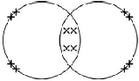
electrons can be shown as dots, crosses, e or any combination
2 bonding pairs
accept 4 electrons within the overlap
1
2 lone pairs on each oxygen
accept 4 non-bonding electrons on each oxygen
1
(c) lattice / regular pattern / layers / giant structure / close-packed arrangement
1
(of) positive ions or (of) atoms
1
(with) delocalised / free electrons
reference to incorrect particles or incorrect bonding or incorrect structure = max 2
1
[7]
Q10.
(a) atoms
1
(b) mixture
1
metal
1
structure
1
smart
1
(c) (i) any two from:
• saves raw materials / iron ore
• saves energy / fuels
accept cheaper / saves money
• make new / useful items
• make money / it is economic
• reduces pollution
allow less harmful for the environment
• decreases cost of steel cans
• reduces carbon dioxide emissions
• decreases waste materials / use of landfill
2
(ii) any one from:
• provide information / education of the need to recycle
• legislate against / charge for waste
• reward / pay people to recycle
accept fine people for not recycling
• put labels on the cans
• provide recycling bags / bins / areas
1
[8]

Q11.
(a) any two from
assume it = methanol
allow converse for water
• shorter / quicker soaking time
allow it is quicker
• takes less time / quicker to dry
or faster evaporation
• dissolves quicker / better in methanol
2
(b) (i) CH₄O
1
(ii) covalent
1
(c) it is made of small molecules
1
[5]
Q12.
high melting point
reference to incorrect bonding or incorrect particles or incorrect structure = max 3
accept will not melt (at high temperatures)
ignore withstand high temperatures
1
because a lot of energy needed to break bonds
1
because it is covalent or has strong bonds
accept bonds are hard to break
1
and because it is a giant structure or a macromolecule or a lattice
ignore many bonds
1
[4]
Q13.
(a) has delocalised electrons
accept free (moving) electrons
1
(so electrons) can move through the structure/metal
accept (so electrons) can carry charge through the structure/metal
accept (so electrons) can form a current
1
reference to incorrect particles or incorrect bonding or incorrect structure = max 1
(b) giant structure
accept lattice
accept each atom forms four bonds (with other carbon atoms)
ignore macromolecular
1
strong bonds
accept covalent
do not accept ionic
1
reference to intermolecular forces/bonds or incorrect particles = max 1
(c) thermosetting polymers do not melt (when heated)
accept thermosetting polymers do not change shape (when heated)
accept thermosetting polymers have high(er) melting points
ignore thermosetting polymers do not soften (when heated)
1
due to cross-links (between chains)
accept due to bonds between chains
1
reference to smart polymers = max 1
accept converse argument
[6]
Q14.
(a) (i) giant lattice
allow each carbon atom is joined to three others
1
atoms in graphene are covalently bonded
max. 2 marks if any reference to wrong type of bonding
1
and covalent bonds are strong or need a lot of energy to be broken
allow difficult to break
1
(ii) because graphene has delocalised electrons
allow each carbon atom has one free electron
1
which can move throughout the structure
do not accept just electrons can move.
1
(b) because there are weak forces between molecules
allow no bonds between the layers
1
so layers / molecules can slip / slide.
1
[7]

