GCSE AQA Biology

Cell Transportation

Name: ____________________________

Contents
Lesson number and topic | Attendance | Retrieval Score
1 Difussion
2 Osmosis
3 Osmosis Required Practical
4 Active Transport
6 Exchange Surfaces

Teacher Comment: | Next Steps:
Student Comment:

Date:____________________________
Diffusion
LO – What is diffusion and what can affect it?
Reading
Diffusion is the movement of particles from an area of high concentration to an area of low concentration. This goes down the concentration gradient. It is a passive process and therefore does not require energy:

Imagine a ball on a slope. The ball will not require you to add energy in order for it to roll down the slope
Concentration gradient
High Concentration
Low Concentration

This of when you spray perfume. At first you can’t smell it and then gradually the particles diffuse across the space until they are evenly spread out and you can smell it.

There are a few different conditions that will speed up the rate of diffusion. If the concentration gradient is very small (there is only a slight difference in the amount of particles) then the rate of diffusion is slower. If the temperature is higher, the rate of diffusion increases because the kinetic energy store of the particles increases and the particles move faster.

Your cells need to take in substances like glucose and oxygen to survive and remove substances like urea and carbon dioxide. Dissolved substances and gases can move in and out of cells by diffusion. The bigger the difference in concentration between two areas the faster diffusion will occur. The oxygen you need for respiration passes from the air into your lungs. From here it diffuses into red blood cells to be transported round the body to where it is needed, for example in muscle cells. Carbon dioxide will diffuse from the blood into the lungs.
The single most common adaptation to improve diffusion is to increase the surface area of a cell. This is commonly done by folding the cell membrane.

SLOP Questions – Answer these on A4 lined paper.
- What substances commonly enter cells?
_______________________________________________________________________________________________
_______________________________________________________________________________________________
_______________________________________________________________________________________________
- What substances are commonly removed by cells?
_______________________________________________________________________________________________
_______________________________________________________________________________________________
_______________________________________________________________________________________________
- Define diffusion
_______________________________________________________________________________________________
_______________________________________________________________________________________________
_______________________________________________________________________________________________
- What is the function of the cell membrane?
_______________________________________________________________________________________________
_______________________________________________________________________________________________
_______________________________________________________________________________________________
- State two factors that can affect diffusion
_______________________________________________________________________________________________
_______________________________________________________________________________________________
- Why does increased temperature increase diffusion?
_______________________________________________________________________________________________
- What diffuses from your lungs into red blood cells?
_______________________________________________________________________________________________
- What diffuses from your red blood cells to your muscle cells?
_______________________________________________________________________________________________
- State two factors that can affect diffusion
_______________________________________________________________________________________________
_______________________________________________________________________________________________
- Describe the process of diffusion including any adaptations for the following statements:
- Carbon dioxide moves from the blood in the capillaries of your lungs to the air in the lungs
_______________________________________________________________________________________________
_______________________________________________________________________________________________
_______________________________________________________________________________________________
_______________________________________________________________________________________________
_______________________________________________________________________________________________

- Male moths can track down a mate from up to 3 miles away because of the special chemicals produced by the female
_______________________________________________________________________________________________
_______________________________________________________________________________________________
_______________________________________________________________________________________________
_______________________________________________________________________________________________
_______________________________________________________________________________________________
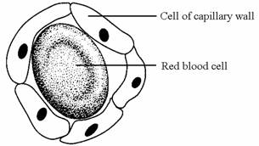
- Capillaries are blood vessels in the body which join the arteries to the veins. They have walls which are one cell thick and so are able to exchange substances with the body cells.

a) Name two substances that travel from the muscle cells to the blood in the capillaries.
_______________________________________________________________________________________________
_______________________________________________________________________________________________
b) Glucose is one substance that travels from the blood in the capillaries to the body cells. Explain how this happens.
_______________________________________________________________________________________________
_______________________________________________________________________________________________
_______________________________________________________________________________________________
_______________________________________________________________________________________________
_______________________________________________________________________________________________

Date:____________________________
Osmosis
LO – How does water move in and out of cells?
Reading
Osmosis is defined as the movement of water from an area of high concentration to low concentration through a semi-permeable membrane. . A partially permeable membrane is one that only lets certain substances pass through and not others. This is a special case of diffusion. It is important to realise that a solution that has a high concentration of water is called a dilute solution, because it has a low concentration of solute dissolved. Conversely, a low concentration of water is found in a concentrated solution as there is less water and more dissolve solute.
Water moves from Dilute Solution to Concentrated solution

Concentrated solution- Lower concentration of water
Dilute solution- Higher concentration of water

If the water concentration outside the cell is equal to the water concentration inside the cell the solution is termed isotonic. A hypotonic solution has a higher water concentration that the cell this means water moves from the solution into the cell. Finally, a hypertonic solution is one in which the water concentration in the solution is lower than the cell causing water to move from the cell into the solution.

If an animal cell absorbs too much water it can burst conversely it can shrivel if it loses too much water. Plant cells do not do either of these as they have a cell wall that keeps them rigid and supports them.
Plant cells have a cell wall that prevents them from bursting or shrivelling when put in different solutions. Instead when in a hypotonic solution water moves into a plant cell and causes them to swell and appear turgid. When in a hypertonic solution the plant cell will lose water and appear plasmolysed. A plant cell is described as plasmolysed when a plant cell membrane pulls away from the cell wall.
Plant cell is…
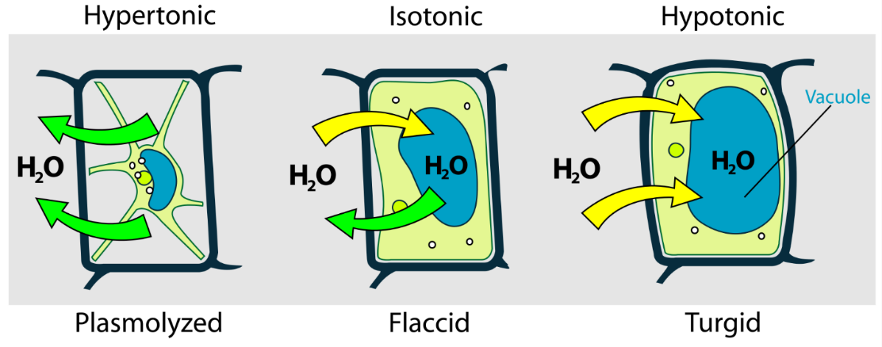

SLOP Questions
- What is a partially permeable membrane?
_______________________________________________________________________________________________
_______________________________________________________________________________________________
_______________________________________________________________________________________________
- What is osmosis?
_______________________________________________________________________________________________
_______________________________________________________________________________________________
_______________________________________________________________________________________________
- What is one similarity between diffusion and osmosis?
_______________________________________________________________________________________________
_______________________________________________________________________________________________
_______________________________________________________________________________________________
- What is a passive process?
_______________________________________________________________________________________________
_______________________________________________________________________________________________
_______________________________________________________________________________________________

- Define isotonic, hypotonic and hypertonic
_______________________________________________________________________________________________
_______________________________________________________________________________________________
_______________________________________________________________________________________________
- What happen to a red blood cell placed in a hypotonic solution?
_______________________________________________________________________________________________
_______________________________________________________________________________________________
_______________________________________________________________________________________________
- What happens to a root hair cell placed in a hypotonic solution?
_______________________________________________________________________________________________
_______________________________________________________________________________________________
_______________________________________________________________________________________________
- Why do the two cells respond differently?
_______________________________________________________________________________________________
_______________________________________________________________________________________________
_______________________________________________________________________________________________

OSMOSIS REQUIRED PRAC SHEET

Date:____________________________
Active Transport
L.O – To learn what active transport is and how it is different from diffusion and osmosis.
Reading
Active transport is the movement of substances from a low concentration to a high concentration through a semi-permeable membrane. This means moving against the concentration gradient and therefore requires energy. The energy is provided by respiration in the mitochondria. This means active transport is only used in vital processes. Like diffusion and osmosis a high surface area is used to increase the rate of active transport

Imagine a ball on a slope. The ball will not roll up the slope unless you give it energy.
High Concentration
Concentration gradient

Low Concentration

Active transport has many important roles. Two examples are below:
- Allow mineral ions to be absorbed into plant root hair cells from very dilute solutions in the soil. Plants require ions for healthy growth, so this movement is vital
- Allow sugar molecules to be absorbed from lower concentrations in the gut into the blood which has a higher sugar concentration. Sugar molecules are used for cell respiration, which is needed to produce energy.

SLOP Questions
- What is active transport?
_______________________________________________________________________________________________
_______________________________________________________________________________________________
_______________________________________________________________________________________________
- What are two differences between active transport and diffusion?
_______________________________________________________________________________________________
_______________________________________________________________________________________________
_______________________________________________________________________________________________
- What is a similarity between diffusion and active transport
_______________________________________________________________________________________________
_______________________________________________________________________________________________
_______________________________________________________________________________________________
- What two adaptations do cells that carry out active transport have?
_______________________________________________________________________________________________
_______________________________________________________________________________________________
_______________________________________________________________________________________________
- Why is active transport important for root hair cells?
_______________________________________________________________________________________________
_______________________________________________________________________________________________
_______________________________________________________________________________________________

Active transport, diffusion osmosis venn diagram

Date:____________________________
Exchange Surfaces
L.O – To learn why the surface area to volume ratio is important
Reading
The bigger the surface area to volume ratio the better an organism it at exchanging material. As animals become larger their surface area to volume ratio becomes smaller. This means that simple diffusion cannot be used to supply all cells with gases and food molecules and poisonous substances can build up in cells. To prevent this larger organisms have evolved complex exchange systems.
These exchange systems share certain common adaptations: large surface area over which exchange can take place, thin membrane to provide a short diffusion distance, efficient blood supply to maintain a steep concentration gradient.
Examples of adapted exchange surfaces include the alveoli which are numerous to provide a large surface area, and a very rich blood supply. The small intestine has many villi and microvilli to increase surface area, a rich blood supply to maintain a steep concentration gradient. The villi are thin to provide a short diffusion distance. This increases the rate at which nutrients like glucose can be absorbed.
Fish gills contain many filaments to increase surface area, there is also a constant supply of water running over the gills to maintain a steep concentration gradient, and the gills also have a rich blood supply for the same reason.
SLOP Questions
- What affect does becoming larger have on surface area to volume ratio?
_______________________________________________________________________________________________
_______________________________________________________________________________________________
_______________________________________________________________________________________________
- What affect does becoming smaller have on surface area to volume ratio?
_______________________________________________________________________________________________
_______________________________________________________________________________________________
_______________________________________________________________________________________________
- What are three common adaptations of exchange surfaces?
_______________________________________________________________________________________________
_______________________________________________________________________________________________
_______________________________________________________________________________________________
- Why is a thin membrane useful?
_______________________________________________________________________________________________
_______________________________________________________________________________________________
_______________________________________________________________________________________________
- Why do alveoli have a rich blood supply?
_______________________________________________________________________________________________
_______________________________________________________________________________________________
_______________________________________________________________________________________________
- What do fish gills contain to increase their surface area?
_______________________________________________________________________________________________
_______________________________________________________________________________________________
_______________________________________________________________________________________________
- What is absorbed in the villi?
_______________________________________________________________________________________________
_______________________________________________________________________________________________
_______________________________________________________________________________________________

