B4 Bioenergetics Mastery Booklet
Part 1- Photosynthesis
Photosynthesis is a chemical reaction that happens in plants and green algae. It is one of the most important chemical reactions in the history of life. It was responsible for creating an oxygen-rich atmosphere approximately 2.3 billion years ago and the evolution of humans, and most other complex life, would not have been possible without it.
Plants and algae carry out photosynthesis to create their own food. Photosynthesis occurs in the chloroplast of these cells. The chloroplasts contain chlorophyll which absorbs light. The chlorophyll also gives a leaf its distinctive green colour. Photosynthesis is an endothermic reaction meaning it requires an input of energy from the environment.
Symbol Equation
6CO2 + 6H2O C6H1206 + 6O2
Word Equation
carbon dioxide + water oxygen + glucose

Symbol Equation
6 CO2 + 6 H2O C6H1206 + 6 O2

Some of the glucose produced during photosynthesis is used immediately in respiration. The rest of the glucose is converted into cellulose to make cell walls, starch for storage, or combined with nitrates to make proteins. The presence of starch in a leaf can be tested using iodine which goes purple/black. This is the standard laboratory test for starch.
Plant leaves are adapted to make photosynthesis as efficient as possible. They are broad to give a large surface area to absorb sunlight. They are thin to give a short diffusion distance for gases to move in and out. They contain lots of chlorophyll to absorb lots of sunlight. They have veins which bring plenty of water to the leaf via the xylem which is used in photosynthesis. They have air spaces which allow carbon dioxide to get to the cells and oxygen to leave by diffusion. They have guard cells that open and close the stomata to regulate gas exchange and prevent water loss by transpiration.

- What are the reactants in photosynthesis?
- Where does photosynthesis take place in the cell?
- What part of a cell absorbs sunlight?
- State three uses of glucose in plants
- Explain the function of veins in plants
- List and explain three other adaptations of a leaf
- Some leaves have white parts why does photosynthesis not occur in these parts?
- What chemical is used to test for starch?
- What is the function of the guard cells?
- Why is photosynthesis an endothermic reaction?

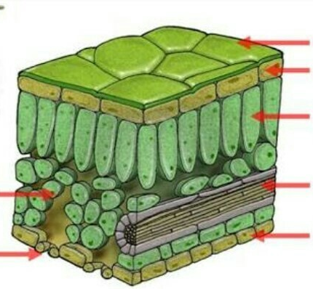
- Label the leaf structures using the following key words: Upper epidermis, spongy mesophyll, waxy cuticle, vein (containing xylem and phloem), lower epidermis, palisade, guard cells.

- Complete the flow diagram below to show the journey of a carbon atom from carbon dioxide in the air to being part of a starch molecule in the plant cell.
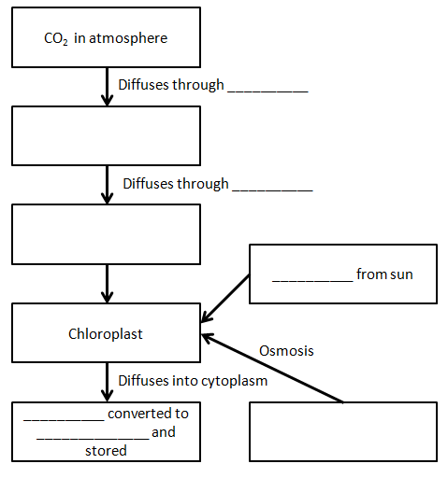
- Describe the journey of a carbon atom from the atmosphere to being stored as a starch grain. Make sure you include the cells and tissues involved and the method of transport.
Key words to use: Subsequently, prior to this, this is followed by, initially, at the beginning, the result of this,
Initially the carbon dioxide required to photosynthesis is found in… It then diffuses into the air spaces through the….
- Explain why a leaf kept in the light for 24 hours will turn an iodine solution blue-black, whereas a leaf kept in the dark for 24 hours will have no effect on iodine solution.
- Bobby says “The three reactants for photosynthesis are water, sunlight and carbon dioxide” are they correct? Give a reason for your answer.
- In 1018 AD the carbon dioxide was at 280 ppm (parts per million). In 2018 it was 410ppm. Calculate the percentage increase in carbon dioxide in the last 1000 years.
- Complete the sentences below
Green Algae can photosynthesise because…..
Green Algae can photosynthesis but…..
Green Algae can photosynthesise so….

Part 2- The rate of photosynthesis.

Photosynthesis is an enzyme controlled reaction. As such the rate of reaction will be affected by the concentration of reactants and the temperature, just like any other reaction.
Plants need light, warmth and carbon dioxide if they are to photosynthesise and grow as fast as they can. Sometimes one of the above can be short supply and limit the amount of photosynthesis a plant can manage. This is why they are known as limiting factors.
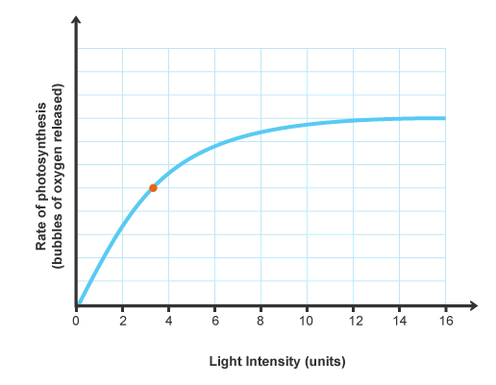
As light intensity increases the rate of photosynthesis also increases. Photosynthesis is an endothermic reaction and therefore requires light energy to function. After a while the rate becomes constant. This is due to another limiting factor (eg CO₂ preventing the rate increasing HT: As a plant gets further from a light source the amount of light energy that hits the plant is governed by the inverse square law. $light ∝ \frac{1}{{distance}^{2}}$
This means that if you double the distance the plant receives ¼ of the light energy.

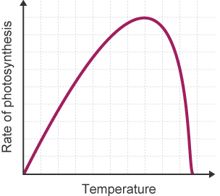
Initially as temperature increases the rate of photosynthesis increases as well. This is caused by the reactants having more kinetic energy, increasing the frequency and proportion of successful collisions. However, at about 40^{O}C the enzymes that carry out photosynthesis become denatured. This means the enzymes lose their shape and their active site is no longer complementary to the substrate and the two cannot bind. At this stage the rate of photosynthesis decreases.

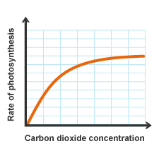
Plants need carbon dioxide to make glucose. The atmosphere is only 0.04% carbon dioxide which means carbon dioxide is the most common limiting factor. As temperature and light intensity increase naturally throughout the day, levels of carbon dioxide decrease. As you increase carbon dioxide concentration, rate of photosynthesis also increases. The rate begins to level off because another limiting factor (eg light) is preventing the rate increasing

Another factor that affects rate of photosynthesis is the levels of the green pigment chlorophyll. Variegated leaves with white areas grow slower than all green plants. If a plant does not have enough magnesium, it cannot then make chlorophyll.
- Define ‘reactant’
- List the reactants of photosynthesis
- Define ‘enzyme’
- Define ‘denatured’
- What is the word equation for photosynthesis
- State the three limiting factors that affect photosynthesis
- What affect does light intensity have on photosynthesis?
- What affect does temperature have on photosynthesis
- Explain the affect of temperature on photosynthesis?
- What does denatured mean?
- What limiting factors is not an environmental influence?
- What mineral is required to make chlorophyll?
- What are the similarities between rose black spot and a magnesium deficiency?
- Explain in terms of limiting factors why plants growing in a tropical rainforest are so much bigger than the plants that grow in UK woodland and why both are bigger than plants that grow on the arctic tundra?

- Light intensity, temperature and concentration of carbon dioxide are factors that affect the rate of photosynthesis.

Scientists investigated the effects of these three factors on the rate of photosynthesis in tomato plants growing in a greenhouse.

The graph below shows the scientists’ results.

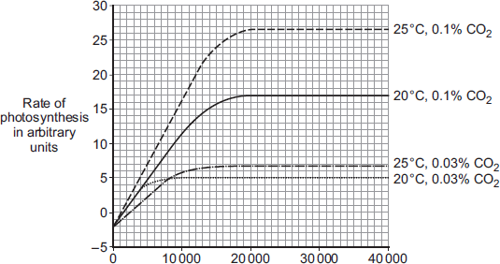
Light intensity in lux

A farmer in the UK wants to grow tomatoes commercially in a greenhouse. The farmer read about the scientists’ investigation. During the growing season for tomatoes in the UK, natural daylight has an intensity higher than 30 000 lux.

The farmer therefore decided to use the following conditions in his greenhouse during the day:

• 20°C

• 0.1% CO₂

• no extra lighting.

Suggest why the farmer decided to use these conditions for growing the tomatoes.

You should use information from the scientists’ graph in your answer.

- (HT ONLY) A student measures the light intensity of a plant 5cm away from a lamp. It is 6000 lux. They moved the plant to 20cm away and measured the light intensity again. Calculate the value on the light meter.
- (HT ONLY) The student replaces the bulb with an LED bulb. At 20cm away it has a light intensity of 10,000 lux. Calculate the new intensity at 5cm.

Part 3- Factors affecting photosynthesis: Required practical
When pondweed photosynthesises, it gives off oxygen bubbles. The rate of photosynthesis can be monitored by counting the bubbles in a specific time. The light intensity can be decreased by moving a lamp further away from the pondweed. A large beaker of water placed between the pondweed and the lamp can be used as a heat shield to stop the pondweed being warmed by the lamp. The pondweed is placed in excess sodium bicarbonate to prevent carbon dioxide from becoming a limiting factor.

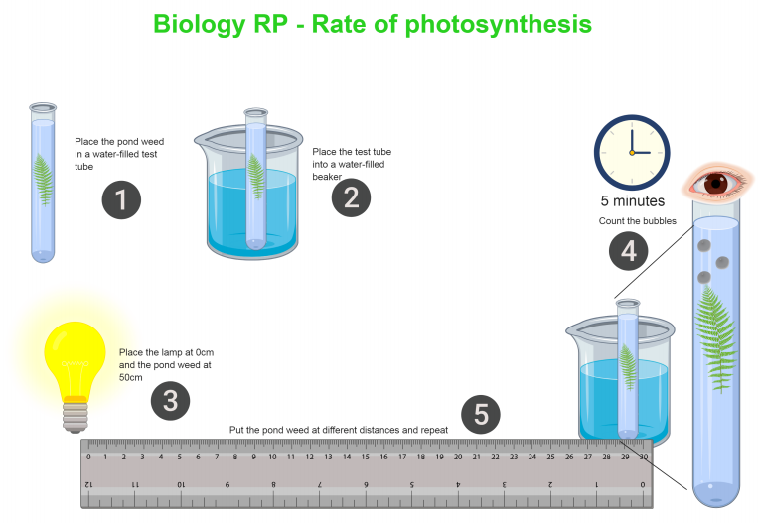
- Identify 3 variables which should be controlled in this investigation
- How could the temperature be controlled in this investigation?
- Identify a possible source of error in the investigation
- What was the purpose of the beaker of water between the pondweed and the lamp?
- Why was an aquatic plant used?
- Why was an excess of sodium bicarbonate solution used?
- What is the dependent variable in this investigation?
- What is the independent variable in this investigation?
- Explain why each experiment was repeated 3 times
- Light intensity, carbon dioxide concentration and temperature are three factors that affect the rate of photosynthesis.

How would you investigate the effect of light intensity on the rate of photosynthesis?

The image below shows some of the apparatus you might use.

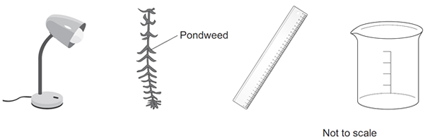

You should include details of:

• how you would set up the apparatus and the materials you would use

• the measurements you would make

• how you could make this a fair test.

- A student investigated the effect of temperature on the rate of photosynthesis in pondweed.

The diagram shows the way the experiment was set up.

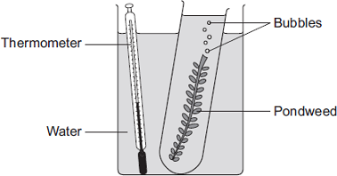

(i) The student needed to control some variables to make the investigation fair.

State two variables the student needed to control in this investigation.

(ii) The bubbles of gas are only produced while photosynthesis is taking place.

What two measurements would the student make to calculate the rate of photosynthesis?

Part 4- How plants use glucose
As previously mentioned plants produce glucose in photosynthesis. Glucose is needed by all cells in plant so they can respire. Without respiration the cell will die. Plant cells also use glucose to build cellulose. This is a tough carbohydrate used to build cell walls.
However, glucose is soluble in water. This means it can dissolve in water. This is a problem as it can affect the water potential of a cell. This means it could affect the way water moves in and out of plant cells by osmosis. This can cause cells to plasmolyze. Instead plants store glucose as starch as it is insoluble and does not affect the water potential of a cell. Starch provides an energy store for plants when it is dark or light levels are low. It is commonly stored in tubers and bulbs. We test for starch using iodine which turns purple-black.
Plants also use glucose by combing it with nitrates to make amino acids which make up proteins. Building these proteins requires both amino acids and energy from respiration.
Some carnivorous plants are adapted to live in mineral deficient soil like bogs (which are wet and peaty) by taking the nitrates they need from the animals they eat. The plants produce enzymes which digest the animals and insects they trap. They then use these nitrates in a similar way to other plants.
Some glucose is also used to make fats and oils. These fats and oils are commonly used as an energy store in seeds.

- Complete the graphic organiser to show the possible fate of glucose molecules
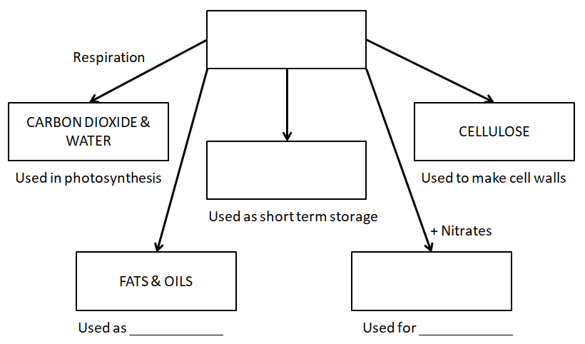
- State three ways the glucose produced by photosynthesis is used
- What is one difference between starch and glucose?
- If a plant is left in the dark for 24 hours what colour will iodine go when added to it?
- What does the white part of a leaf not contain?
- What chemical is used to test for starch?
- Why can’t glucose be stored in plants?
- What does the venus fly trap take from the insects it ingests?
- What is the relationship between photosynthesis and plant seeds
- What are proteins made up of?
- How are proteins made in plants?
- Define ‘osmosis’
- What does semi permeable mean?
- Which cell organelle is semi permeable?
- Angus says “if there is too much glucose in the cell then the water will leave the cell by diffusion as the cytoplasm is hypertonic.” Angus has made 3 mistakes. Write the correct version of the sentence into your books.
- What happens when a cell is plasmolysed?

A plant with variegated (two-coloured) leaves was left in sunlight for several hours. Pieces of one of its leaves were then detached (removed) and tested for sugar. The diagram below shows the results.
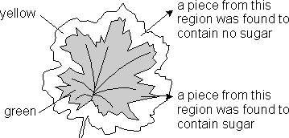
- Explain, as fully as you can, why the yellow region of the leaf had not produced sugar.

- Explain why sundews and venus flytraps can survive in bogs globally, an environment where most other plant species would die.

Part 5- Aerobic respiration
Respiration is an exothermic reaction which releases energy to allow cells to carry out its vital functions. All cells have to respire to survive. Human respiration comes in two forms; aerobic and anaerobic.
Aerobic respiration is an enzyme controlled reaction that takes place in the mitochondria in both plant and animals cells. Aerobic respiration is an exothermic reaction as it releases energy into the surroundings.
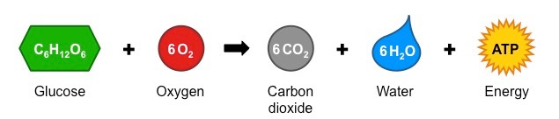
The amount of respiration organisms do will be affected by a number of factors. The more cells they have the more they will respire. Different types of tissue have different energy requirements. Muscles cells contain many more mitochondria than fat cells, so a person with more muscle will need more glucose to provide the energy needed to keep all their cells alive. Mitochondria contain a folded inner membrane which provides a large surface area for aerobic respiration. This helps make them very efficient.
Whilst aerobic respiration takes place in the mitochondria other parts of the cell have an important part of play in it occurring. The nucleus contains the genes needed for making the enzymes used in respiration. The ribosomes create the enzymes needed, as they are made of protein. The cell membrane allows gases and water to enter the cell where they can diffuse into the mitochondria to be used in respiration.
The energy released in respiration is used for the following processes: build large molecules from smaller ones as well as the converse. Energy is also required to make muscles contract, maintain constant temperature as part of homeostasis and for active transport.
- What is the word equation for aerobic respiration
- What are the reactants in aerobic respiration?
- What does aerobic mean?
- Where does aerobic respiration take place?
- How are the ribosomes involved in respiration?
- What is one way mitochondria are adapted to their function?
- Why do muscle cells contain lots of mitochondria?
- State two uses of the energy created in aerobic respiration
- Complete the Venn diagram to compare aerobic respiration to photosynthesis

- Photosynthesis and aerobic respiration are two key chemical processes that happen in plants. Compare the two reactions. Make sure you include their similarities and their differences. Key words to use: While, whereas, similarly, contrastingly, in much the same way
The reactants in photosynthesis are… whereas…. .
Aerobic respiration occurs in the… contrastingly….

- Explain why muscle cells have many mitochondria but fat cells have few
- Suggest why root hair cells have lots of mitochondria
- Describe how the different structures in a cell work together to carry out aerobic respiration

Part 6- Anaerobic Respiration

Everyday muscle movements use energy provided by aerobic respiration but when exercising hard muscle cells can become short of oxygen. When this is the case anaerobic respiration is used to release energy. In anaerobic respiration glucose is not broken down completely unlike aerobic respiration and less energy is released. This means it is not preferred, and cells only respire anaerobically when they cannot respire aerobically
In animals anaerobic respiration occurs as follows:
glucose lactic acid
If using anaerobic respiration for a long time muscles become fatigued. This is because of lactic acid building up. Lactic acid lowers the pH which can affect and denature enzymes. You feel this as a burning sensation in the muscle. The oxygen debt is the amount of oxygen needed to break down the lactic acid that built up. Lactic acid is broken down to carbon dioxide and water. Consider a sprinter, after the race they are breathing heavily. They might have ran for only 11 seconds, but most of the time they were respiring anaerobically. This means they have a large oxygen debt they must repay, so they breathe deeply.
Anaerobic respiration also occurs in plants and microorganisms but is slightly different. The products are used in brewing and making bread.
glucose ethanol + carbon dioxide
Yeast are unicellular fungi that are commonly used to make alcoholic drinks and bread. This is of use to us now, but was even more important earlier in human history. As early as 3000BC beer and wine were considered important drinks. This was because water was often contaminated with pathogens so unsafe to drink. By fermenting a very dilute beer, people were able to sterilise the water and drink it safely.
- When does anaerobic respiration take place?
- What is an oxygen debt?
- What causes muscle fatigue
- What is one way anaerobic respiration in plants and humans is different?
- How do humans use anaerobic respiration in yeast?
- What is lactic acid broken down into?
- Why do organisms not use anaerobic respiration all the time
- What does anaerobic mean?
- What does unicellular mean?
- What organelles will be present in both yeast and plant cells?
- What organelles will be present in both yeast and muscle cells?
- Why was brewing important in medieval times?
- Gina says “humans need to breathe in oxygen to keep them alive” This is true but lacks detail. Re-write Gina’s answer to as much detail as possible.
- Complete the venn diagram to compare aerobic and anaerobic respiration.

- Respiration is a vital chemical process that occurs in all living cells. Use the information you have learned so far to explain what respiration is, why it is important and compare the two versions that happen.
Key words to use: While, whereas, similarly, contrastingly, in much the same way, A similarity between

The reactants in anaerobic respiration are… whereas…. .
Aerobic respiration occurs in the… contrastingly….
A similarity between both types of respiration is….
- The diagram below shows an experiment to investigate anaerobic respiration in yeast cells.
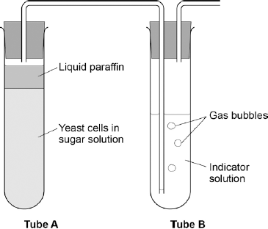

What is the purpose of the liquid paraffin in Tube A?

Choose from:
- To prevent evaporation
- To stop air getting in
- To stop the temperature going up
- To stop water getting in
- The indicator solution in Tube B shows changes in the concentration of carbon dioxide (CO₂).

The indicator is:

• blue when the concentration of CO₂ is very low

• green when the concentration of CO₂ is low

• yellow when the concentration of CO₂ is high.

What colour would you expect the indicator to be in Tube B during maximum rate of anaerobic respiration?

- Suggest how the experiment could be changed to give a reproducible way to measure the rate of the reaction. Include any apparatus you would use.
- Compare anaerobic respiration in a yeast cell with anaerobic respiration in a muscle cell.

Part 7- The body’s response to exercise

When you exercise your muscles contract. They pull against your skeleton to make you move.

Our muscle tissue is comprised of lots of muscle fibres that require lots of energy to contract. Muscle cells typically have lots of mitochondria to carry out aerobic respiration and release lots of energy. Additionally, our muscle cells contain lots of glycogen, which is an insoluble store of glucose (similar to starch). When a muscle cells’ glucose stores run out, the glycogen can be converted back into glucose. Increased exercise leads to an increase need for oxygen and glucose. These both reach the cells via the bloodstream.

The body responds to exercise by increasing the heart rate and dilating (widening) the arteries that supply the muscles with blood. This increases the blood flow to the muscles and therefore the supply of oxygen and glucose to muscle cells. This also allows waste products like carbon dioxide to be removed quicker. Increasing the blood flow increases the rate at which oxygen is delivered to the muscles but the body also need to get more oxygen into the blood. If it fails to do this the muscles will have to respire anaerobically.

As the heart rate increases the body also increases the rate of ventilation (breathing). You begin to breathe more deeply and breathe faster. This means more oxygen is brought into the lungs and binds with haemoglobin in the red blood cells. Also more carbon dioxide is removed from lungs.

HT only: When the body performs extremely powerful movements, like sprinting or lifting weights, it is forced to respire anaerobically. This creates an oxygen debt. In the recovery time afterwards the lactic acid that builds up is transported in the blood to the liver. At the liver the lactic acid is converted back to glucose, using oxygen in the process. Any excess glucose is then stored as glycogen.

- What is one use of energy released by respiration?
- What are two adaptations of muscle cells?
- What is glycogen made of?
- What are three ways our body responds to exercise?
- Describe why each of the responses you selected helps with respiration
- What is glycogen converted into?
- Define ‘diffusion’
- What is the name of the small air sacs in lungs?
- How are they adapted increase the rate of diffusion?
- Why does glucose need to be converted into glycogen to be stored?
- Which part of the heart pumps blood to the body?

Choose from: Left atrium, right atrium, left ventricle, right ventricle
- Which blood vessel type carries blood away from the heart?
- What adaptations does your answer to the question above have to help it carry blood away from the heart?
- HT What happens to the lactic acid made from anaerobic respiration?
- HT Why does a sprinter breathe heavily after running 100m?
- Complete the sentences below:

Humans respires anaerobically because…

Humans respire anaerobically, but……

Humans respire anaerobically, so…
- Glucose is soluble, but glycogen is not. Explain why glucose is stored as glycogen. Use the idea of osmosis in your answer.
- Use the information you have learnt to complete the flow diagram summarising the body’s response to exercise.

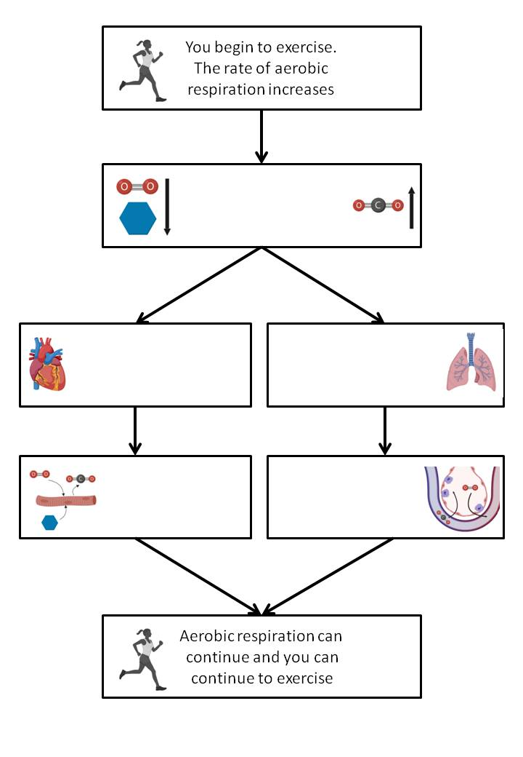

- You are late to lesson on the top floor. Describe and explain the responses your body makes as you run up the stairs to class.
- In an investigation, Person 1 and Person 2 ran as fast as they could for 1 minute. Scientists measured the heart rates and stroke volumes of Person 1 and Person 2 at rest, during the exercise and after the exercise. The stroke volume is the volume of blood pumped in each heart beat. The graph below shows the scientists’ results.

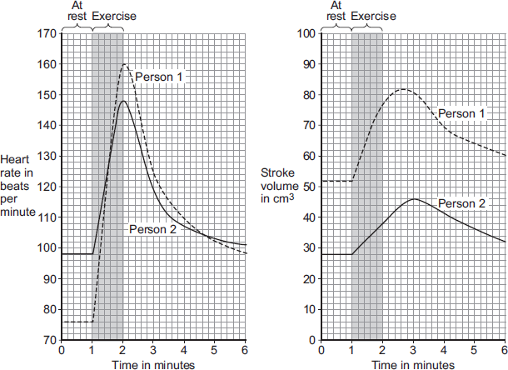

Person 1 was able to run much faster than Person 2.

Use information from Figure above and your own knowledge to explain why (Hint look at meaning of stroke volume)
- An increased cardiac output will provide more oxygen and more glucose to the working muscles. Explain how this helps the athlete during exercise.

Part 8- Metabolism

“Oh you are so lucky you can eat whatever you want without getting fat! You must have a fast metabolism.” This is the common way people use the word metabolism in every day situations. This is not completely wrong. Metabolism is the word used to describe all the chemical reactions in your body. As most of these are exothermic reactions and required energy from respiration then a faster metabolism will need more calories to sustain it.

There are thousands of metabolic reactions taking place in all living organisms. Some of the most important include the conversion of glucose to starch, cellulose and glycogen. In plants, the combination of glucose with nitrates to make amino acids is important for growth and repair. Both respiration and photosynthesis are examples of metabolic reactions.
The role of the liver in metabolism is to detoxify poisonous substances such as ethanol in alcoholic drinks then to transfer the broken down substances to the kidney via the blood where they can be excreted via urine. It is also the job of the liver to break down old worn out blood cells and store the iron until it is needed to make more red blood cells.
The liver also helps remove lactic acid. Blood flowing from the muscles transfers lactic acid to the liver. The lactic acid is then converted back into glucose and then broken down into carbon dioxide and water through aerobic respiration. If there’s no need for extra aerobic respiration then the glucose can be stored as glycogen.
If there is an excess of calories in a person’s diet then their cells will convert some of the molecules of fatty acids and glycerol. These are combined to form lipids (fats) which are stored in the body for use later on.
- Define metabolism
- Give four examples of metabolic reactions
- What is cellulose used for?
- Give one property of starch
- What are two roles of the liver?
- Give two occasions when the amount of blood flowing to and from the liver might increase
- How is the liver involved in the breakdown of lactic acid?
- When is glucose converted to glycogen in the liver?
- What is the name of the organelle which makes proteins form amino acids?
- Would a person who has a higher percentage of muscle have a faster or slower metabolism?
Review and interleaved questions:
- In which sub-cellular structure does photosynthesis occur?
- Explain why photosynthesis can be considered an endothermic reaction?
- What two chemical reactants are required for photosynthesis?
- What adaptations of the leaf allow the gas to reach photosynthesising cells?
- Which plant tissue transports water to the leaf?
- State two adaptations of this tissue
- Explain why a leaf can be considered an organ.
- What provides the energy required for photosynthesis?
- Which chemical absorbs light energy?
- Where in the plant cell is this chemical found?
- What are the two products of photosynthesis?
- Which of these products contains the most stored chemical energy?
- Which plant tissue transports this substance to other parts of the plant?
- Show the reactants and products of photosynthesis as chemical symbols.
- Write a balanced chemical equation for photosynthesis
- What are the four potential limiting factors for photosynthesis?
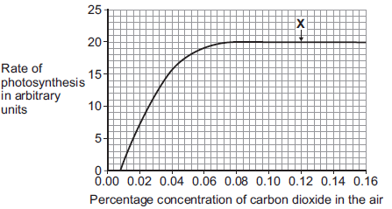
- What happens to enzyme activity as temperature increases?
- How does this affect the rate of photosynthesis?
- In nature, why are plants’ enzymes unlikely to denature?
- Why is water not considered a limiting factor for photosynthesis?
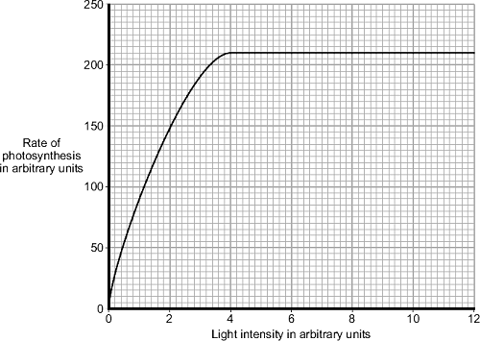
- Why do dry, hot conditions limit or prevent photosynthesis (hint – not because enzymes denture)?
- In graph 1, what is the maximum rate of photosynthesis?
- In graph 1, the rate of photosynthesis is not limited by carbon dioxide concentration. What might be limiting the rate?
- Explain how you can tell that carbon dioxide concentration is not limiting the rate at point X.
- On graph 2, at which range of light intensities is light a limiting factor?

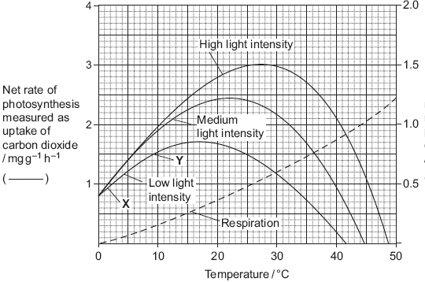
- What could be limiting photosynthesis at a light intensity of 8 arbitrary units?
- (HT) On graph 3, what factor could be limiting photosynthesis between point X and Y?
- (HT) At 8°C, what is limiting photosynthesis for plants at medium and high light intensity?
- (HT) What could be limiting plants at high light intensity at 25°C?
- A heated greenhouse with lighting would provide good conditions for photosynthesis in winter. Why might growers not want to heat and light their greenhouses?
- Give five uses of the glucose made by photosynthesis
- Name two processes that cells need energy for
- What process involves the movement of water due to differences in concentration?
- Why is storing glucose as starch useful for plants?
- Which enzyme breaks down starch?
- Which plant cells have a large surface area for absorption of water and minerals?
- Which other chemical is required to make amino acids?
- How do plants obtain this nutrient?
- Which enzyme breaks down proteins to amino acids?
- Why is respiration described as an exothermic reaction?
- What are the reactants for aerobic respiration?
- Which of these does anaerobic respiration not require?
- Which type of respiration transfers the most energy?
- Energy can be used for making large molecules, give three examples of plants using energy to make large molecules.
- Which type of cellular transport requires energy?
- Give two other uses of energy
- Write the word and balanced symbol equation for aerobic respiration
- Which structure in fish provides the oxygen?
- Describe a structural adaptation that is similar between fish gills and lungs.
- Write the word equation for anaerobic respiration in muscle cells.
- In terms of oxidation of glucose, explain why less energy is transferred by anaerobic respiration.
- Write the word equation for anaerobic respiration in plant cells and yeast.
- In what conditions might plant cells not have enough oxygen?
- What name is given to anaerobic respiration in yeast (and other microbes)?
- What useful products are obtained using anaerobic respiration in yeast?
- What happens to our energy demand when we exercise?
- So what happens to the amount of aerobic respiration we do?
- How does our body provide the extra oxygen and glucose required?
- What product of anaerobic respiration causes cramp?
- Which organ breaks down the lactic acid after exercise?
- What is the lactic acid converted into?
- How does the lactic acid get from muscles to the organ?
- Why is this called oxygen debt?
- What is metabolism?
- Give three examples of reactions that this would include?
Name the small molecules are used to make:
- Starch
- Proteins
- Lipids
- Cellulose
- Which enzyme breaks down lipids?
- Where is this enzyme made?
- What role does the gallbladder have in the digestion of lipids?
- What role does the liver have?
- How does bile increase the rate of lipid digestion?

