GCSE AQA Biology

Cell Organisation
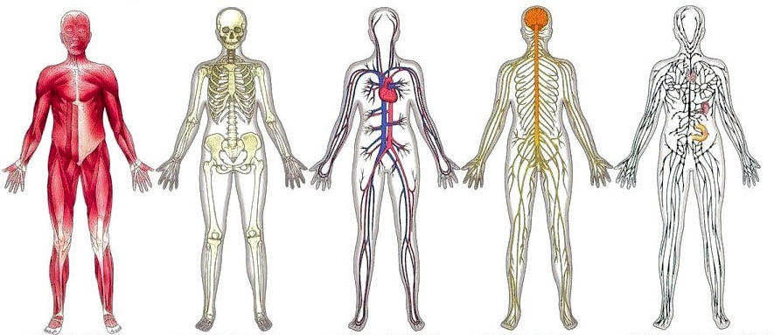
Part 1

Name: ____________________________

Contents
Lesson number and topic | Attendance
1 Tissues and organs
2 The digestive system
3 The chemistry of food
4 Food tests required practical
6 Enzymes
7. Digestive enzymes
8. Factors affecting enzymes required practical.

Teacher Comment: | Next Steps:
Student Comment:

Date:____________________________
Tissues and organs
LO –
Starter – Label as many internal organs as you can below
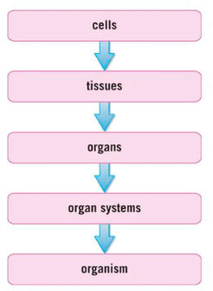
Reading
Cells are the building blocks of life. Eukaryotes cells are more complex that prokaryotic cells and this allows them to form multi-cellular life forms, like humans, daisies, mushrooms and grasshoppers. To form a multi-cellular life cells, need to differentiate into specialised cells.

Groups of similar cells that work together to carry out a particular function make up tissues. Examples of tissues include muscle tissue (which contracts), epithelial tissue (which covers the outside of the body or around organs) and glandular (which secrete mucus, enzymes or hormones).
Groups of tissues that work together to carry out a particular function make up organs. An example of an organ is the stomach. The stomach is made up of muscular tissue, glandular tissue and epithelial tissue. Other examples of organs include heart, brain, skin, pancreas, and kidney. The pancreas has two important functions creating the hormones that control blood glucose concentration and producing enzymes used in digestion.

Groups of organs that work together to carry out a particular function make up organ systems. An example of an organ system is the digestive system and it is made up of organs such as the mouth, stomach, small intestine and large intestine to name a few.
Other examples of organ systems include reproductive system, circulatory system and respiratory system.

Groups of organ systems that work together to carry out a particular function make up an organism.

Complete the table below

Increasing size  Increasing complexity | Organisational levels | Definition | Example
 | Tissue | A group of specialised cells the perform the same function | Muscle
SLOP Questions
- Define ‘tissue’.
_______________________________________________________________________________________________
_______________________________________________________________________________________________
_______________________________________________________________________________________________
- Define ‘organ’.
_______________________________________________________________________________________________
_______________________________________________________________________________________________
_______________________________________________________________________________________________
- The stomach contains mainly three types of tissues. State their functions.
a.) Muscular tissue
_______________________________________________________________________________________________
_______________________________________________________________________________________________
_______________________________________________________________________________________________
b.) Glandular tissue
_______________________________________________________________________________________________
_______________________________________________________________________________________________
_______________________________________________________________________________________________
c.) Epithelia tissue
_______________________________________________________________________________________________
_______________________________________________________________________________________________
_______________________________________________________________________________________________
- Re-arrange the following parts of the body in the correct organisational levels Tissue, Organ system, Cell, Organism, Organ.
_______________________________________________________________________________________________
_______________________________________________________________________________________________
_______________________________________________________________________________________________
- Matt says “The skin is an organ because it is made from epithelial, muscle and glandular tissue.” Is he correct? Give a reason.
_______________________________________________________________________________________________
_______________________________________________________________________________________________
_______________________________________________________________________________________________
Date:____________________________
The digestive system
LO –
Reading
Digestion involves breaking down large molecules into smaller molecules. This increases their surface area, making them soluble. This is important because these large molecules are too big to be absorbed into our blood at the small intestine.

Digestion

This process occurs throughout the digestive system. The function of the digestive system is to digest and absorb nutrients from food. This is mainly water, protein, carbohydrates and fats.

SLOP Questions
- What is meant by digestion?
_______________________________________________________________________________________________
_______________________________________________________________________________________________
_______________________________________________________________________________________________
- Why is digestion important to us?
_______________________________________________________________________________________________
_______________________________________________________________________________________________
_______________________________________________________________________________________________
- Explain why the digestive system is an organ system.
_______________________________________________________________________________________________
_______________________________________________________________________________________________
_______________________________________________________________________________________________
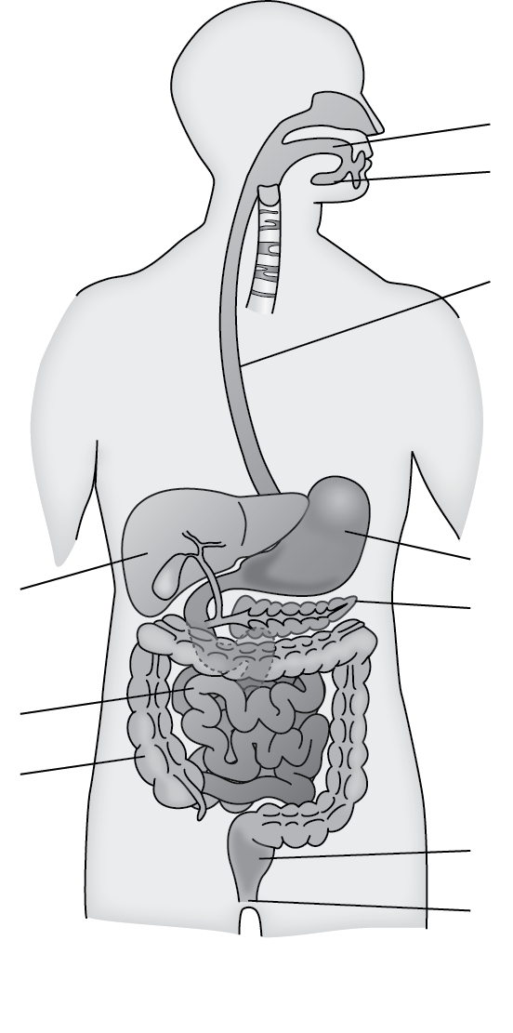
Label the organs in the digestive system below

Your digestive system is up to 9m long. These organs include the salivary gland and pancreas that produce enzymes, the liver that produces bile which emulsifies, the stomach that produces certain enzymes and hydrochloric acid. The small intestine is a muscular tube that can contract to move food along it. It also produces and secretes enzymes.
The large intestine absorbs water and contains bacteria to break down any undigested food

In the mouth
- Mechanically breaks food down through chewing.
- Salivary glands produce the enzyme Amylase which breaks down starch into glucose.

The stomach
- A muscular bag which churns food to break it down and into smaller molecules
- Contains Hydrochloric acid which breaks up food molecules.
The Liver and gall bladder
- The liver produces an alkali called bile which is stored in the gall bladder.
- Bile neutralises the stomach acid, providing the optimum conditions for the digestive enzymes to break down food.
- Bile emulsifies fats, breaking them up into smaller droplets making absorption faster.
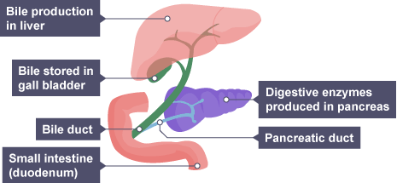
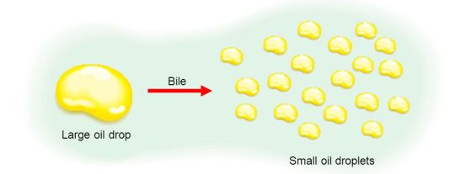

The pancreas produces digestive enzymes such as amylase, protease and lipase as the food enters the small intestine. Here, protein, fat and carbohydrates are broken down into smaller, soluble molecules and absorbed into the bloodstream by diffusion.

SLOP Questions
- What is the only food group broken down by enzymes in the mouth?
_______________________________________________________________________________________________
_______________________________________________________________________________________________
___________________________________________________________________________

- How does the stomach increase the surface area of food?
_______________________________________________________________________________________________
_______________________________________________________________________________________________
_______________________________________________________________________________________________
- How does stomach acid aid digestion?
_______________________________________________________________________________________________
_______________________________________________________________________________________________
_______________________________________________________________________________________________
- Where is bile produced?
_______________________________________________________________________________________________
_______________________________________________________________________________________________
_______________________________________________________________________________________________
- What type of chemical is bile?
_______________________________________________________________________________________________
_______________________________________________________________________________________________
_______________________________________________________________________________________________
- What is meant by emulsification?
_______________________________________________________________________________________________
_______________________________________________________________________________________________
_______________________________________________________________________________________________
- How does emulsification make digestion more efficient?
_______________________________________________________________________________________________
_______________________________________________________________________________________________
_______________________________________________________________________________________________
- Where are nutrients absorbed?
_______________________________________________________________________________________________
_______________________________________________________________________________________________
_______________________________________________________________________________________________

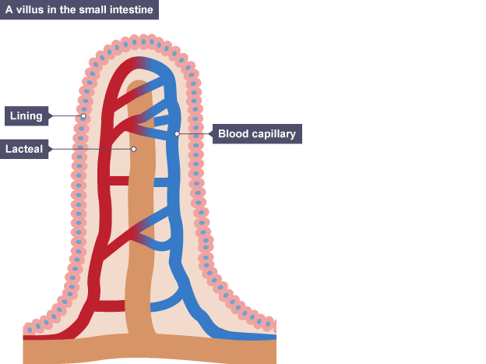
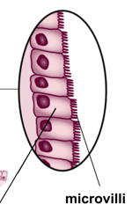
Absorption is the movement of food through the small intestine walls into the blood. The walls are adapted for the absorption of nutrients by having villi, each of which contains thousands of microvilli. This significantly increases the surface area of the intestinal wall. This makes the absorption of nutrients happen quickly.

The nutrients move from an area of high concentration in the small intestines to a low concentration in the blood.

The intestinal wall is one cell thick, providing a short diffusion distance for nutrients.

The large blood supply removes nutrients away quickly. This helps maintain the concentration gradient between the intestines and the blood.
Finally, the left over substances pass through the large intestine where water is re-absorbed.

SLOP Questions

- In what part of the digestive system would you expect villi?
_______________________________________________________________________________________________
_______________________________________________________________________________________________
_______________________________________________________________________________________________
- People with coeliac have an intolerance to gluten. This causes an immune response which damages the surface of the small intestine, destroying the villi. What will happen to the surface area of the small intestine?
_______________________________________________________________________________________________
_______________________________________________________________________________________________
_______________________________________________________________________________________________
- How will this affect digestion?
_______________________________________________________________________________________________
_______________________________________________________________________________________________
_______________________________________________________________________________________________
- Suggest why people with coeliac often struggle to absorb nutrients in food.
_______________________________________________________________________________________________
_______________________________________________________________________________________________
_______________________________________________________________________________________________
- Where is excess water absorbed?
_______________________________________________________________________________________________
_______________________________________________________________________________________________
_______________________________________________________________________________________________

Date:____________________________
The chemistry of food
L.O –
Reading
Carbohydrates, lipids and protein make up most parts of a cell. Therefore, it is important we have lots of them. This makes them the main parts of our diet.
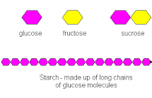
Carbohydrates help provide us with energy. All carbohydrates contain carbon, oxygen and hydrogen. Glucose (C₆H₁₂O₆) is a simple carbohydrate made of a single carbohydrate molecule. Sucrose is also a simple carbohydrate made up of two carbohydrate molecules joined together. Glucose molecules can be combined in long chains to form complex carbohydrates. Examples of this include starch and glucagon which act as energy storage molecules in plants and animals respectively. Carbohydrate rich foods include bread, pasta and potatoes.
Lipids are fats and oils. They are an energy store in our cells. When combined with other molecules they can be used to make cell membranes. Like carbohydrates they are made up of carbon, hydrogen and oxygen. They are insoluble in water. Each lipid molecule is made up of three molecules of fatty acids combined with a molecule of glycerol. Olive oil, vegetable oil, cheese, butter and margarine are all sources of lipids.

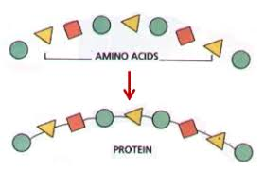
Proteins are polymers made up of amino acids joined together. There are twenty different amino acids which can be combined in different orders to make new proteins. Proteins are used to build our cells and our enzymes. Protein is made up of carbon, hydrogen, oxygen and nitrogen. Protein rich foods include meat, fish and cheese.

Nutrient | Made of | Uses in living organisms | Sources in our diet
Carbohydrate | Carbon, hydrogen and oxygen
Lipids (Fats) |  | Energy store, part of cell membrane
Protein |  |  | Meat, fish, diary

SLOP Questions
- Give two functions of carbohydrates.
_______________________________________________________________________________________________
_______________________________________________________________________________________________
_______________________________________________________________________________________________
- Which atoms make up carbohydrates?
_______________________________________________________________________________________________
_______________________________________________________________________________________________
_______________________________________________________________________________________________
- State the monomer (the basic unit) of carbohydrates.
_______________________________________________________________________________________________
_______________________________________________________________________________________________
_______________________________________________________________________________________________
- Glucose is absorbed by the small intestine no matter how low its concentration in the digested food. Which transport process is used?
_______________________________________________________________________________________________
_______________________________________________________________________________________________
_______________________________________________________________________________________________

- State the chemical formula of glucose.
_______________________________________________________________________________________________
_______________________________________________________________________________________________
_______________________________________________________________________________________________
- Give two examples of complex carbohydrates.
_______________________________________________________________________________________________
_______________________________________________________________________________________________
_______________________________________________________________________________________________
- What types of food contain lots of carbohydrates? Give three examples.
_______________________________________________________________________________________________
_______________________________________________________________________________________________
_______________________________________________________________________________________________
- What are the two types of lipids?
_______________________________________________________________________________________________
_______________________________________________________________________________________________
_______________________________________________________________________________________________
- Which elements make up lipids?
_______________________________________________________________________________________________
_______________________________________________________________________________________________
_______________________________________________________________________________________________
- State two functions of lipids.
_______________________________________________________________________________________________
_______________________________________________________________________________________________
_______________________________________________________________________________________________
- What is the function of the cell membrane?
_______________________________________________________________________________________________
_______________________________________________________________________________________________
_______________________________________________________________________________________________
- What types of food contain lots of lipids? Give two examples.
_______________________________________________________________________________________________
_______________________________________________________________________________________________
_______________________________________________________________________________________________
- What process causes water to move across the cell membrane from a dilute solution to a concentrated one?
_______________________________________________________________________________________________
_______________________________________________________________________________________________
_______________________________________________________________________________________________
- Give two functions of proteins.
_______________________________________________________________________________________________
_______________________________________________________________________________________________
_______________________________________________________________________________________________
- Which atoms make up proteins?
_______________________________________________________________________________________________
_______________________________________________________________________________________________
_______________________________________________________________________________________________
- What makes up proteins?
_______________________________________________________________________________________________
_______________________________________________________________________________________________
_______________________________________________________________________________________________
- Describe how different proteins can be made from the same 3 amino acids
_______________________________________________________________________________________________
_______________________________________________________________________________________________
_______________________________________________________________________________________________

FOOD TEST PRACTICAL SHEET

Date:____________________________
Enzymes
L.O –
Reading

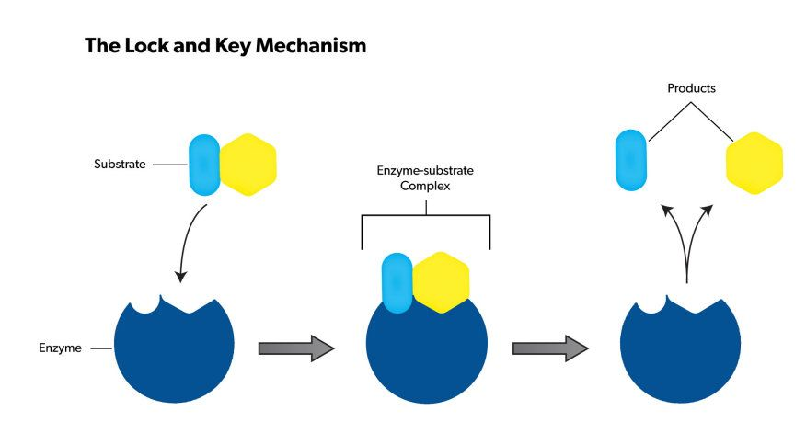
Part 4 Enzymes
Enzymes are proteins. They are incredibly useful and play a role in every process that keep organisms alive. Enzymes are biological catalysts. A catalyst is a substance that speed up a reaction by lowering the activation energy but is not used up. Enzymes can catalyse reactions that break large substances down into smaller ones or build large ones from smaller molecules. Enzyme are incredibly good at doing one specific function. An enzyme is able to bind to only specific molecules (known as the substrate). They have an area called the active site when the substrate(s) bind. This has a very specific shape. A model people use to explain this is the idea of a lock and key. The enzyme is the ‘lock’ and the substrate is the ‘key’. The main role of enzymes in the digestive system is in the breakdown of large insoluble molecules into smaller soluble ones.
The main enzymes in our digestive system are carbohydrases (amylase), protease and lipases.
Carbohydrases digest carbohydrates. Amylase is the carbohydrase which breaks down starch. Amylase is produced in the salivary glands, pancrease and small intestine. Amylase carries out it’s function in the mouth and small intestine. Protease digests protein into amino acids. Protease is produced in the small intestine, stomach and pancreas. Protease is used in the stomach and small intestine. Lipases digest lipids (fats and oils) into three fatty acids and glycerol. Lipase is made in the small intestine and pancreas but is only used in the small intestine. Fats are insoluble in water, so bile is added from the liver to emulsify the fats. This breaks them into small droplets, increasing the surface area so the lipase can work efficiently.
- Use the information above to complete the table.
Enzyme | Substrate | Products | Made in | Works in
Protease | Protein | Amino acids | Small intestine  Stomach  Pancreas | Stomach  Small intestine
SLOP Questions
- What affect does becoming larger have on surface area to volume ratio?
Catalyst | - The enzyme and substrate bound together.
Enzyme | - The special site in the structure of an enzyme where the substrate binds.
Enzyme-substrate complex | - The energy needed for a chemical reaction to take place.
Activation energy | - A substance which changes the rate of a chemical reaction without being changed itself.
Active site | - A biological catalyst.
- Match the following keywords with their functions.

- What are enzymes?
- What is the active site of an enzyme?
- Name the types of enzymes that catalyse the breakdown of:
a.) Carbohydrates
b.) Lipids
c.) Proteins
- Which organs in the digestive system produce digestive enzymes?
- Catalase is an enzyme that speeds up the breakdown of hydrogen peroxide. The enzyme increases the rate of reaction so it is 700 times faster. If the enzyme reaction took 1.9s how long would the reaction take if there was no enzyme? Convert the answer to minutes. Give your answer to 4sf.

Date:____________________________
Digestive enzymes
L.O –
Reading
Biological reactions are affected by the same factors as any other chemical reaction: concentration, temperature, and surface area. We are going to focus on the effect of two variables on enzyme-controlled reactions: temperature and pH.
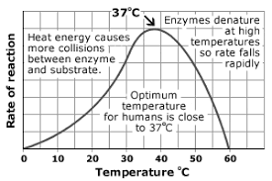
An increase in temperature will increase the rate of an enzyme-controlled reaction up to a certain amount. After about 41^{O}C the enzymes will start to become denatured. When an enzyme is denatured it loses its shape, the active site can no longer bind to the substrate and no enzyme-substrate complexes are formed. When temperature is too low the reaction is slow because the enzymes don’t have much kinetic energy and so rarely collide with their substrate
The graph to the right shows how enzymes in the human body are affected by temperature. But some extremophiles (organisms that live in extreme environments) have enzymes that work at temperatures up to 80^{O}C.
Each enzyme has an optimum pH, outside of this pH the enzyme becomes less effective and eventually can be denatured. This is because the forces that hold the enzyme together are weakened and the active site can change shape preventing the formation of enzyme-substrate complexes.
Glands in the stomach release a protease known as pepsin. This pepsin is adapted to work at low pH (acidic). The stomach also produces hydrochloric acid to ensure that pepsin can work most effectively. The stomach produces a thick layer of mucus which coats your stomach and prevents the hydrochloric acid from digesting the walls of the stomach. After being digested in the stomach, food moves into the small intestine. The enzymes in the small intestine, such as pancreatic amylase, prefer an alkaline environment. To produce an alkaline environment bile is produced in the liver. Bile is stored in the gall bladder and is then released into the small intestine to neutralise the acidic solution coming from the stomach. Bile has another job. It emulsifies the fats in our food. This increases the surface area of the fat molecules and allows lipase to break down fats faster.
SLOP Questions
- What affect does becoming larger have on surface area to volume ratio? What does denatured mean?
- What happens to enzymes when the temperature is:
- a.) Too low
- b.) Too high
- Explain the effects of temperature on enzyme action.
- What is the optimum temperature for enzymes in the human body?
- What holds enzymes together?
- How does a change in pH cause enzymes to denature?
- Using the graph given, calculate the rate of reaction of the enzyme. Remember to include units.
- What is pepsin?
- Where is bile produced?
- State where bile is stored
- What are two differences between pepsin and pancreatic amylase?
- What is the difference between pepsin and proteases produced by the pancreas?
- What are the functions of hydrochloric acid in the stomach?
- How is the stomach adapted to protect itself from pepsin and the hydrochloric acid?
- Suggest the optimum pH for enzymes to work in the small intestine.
- Suggest the optimum pH for enzymes to work in the stomach
- What happens to an enzyme outside its preferred pH?
- What else can cause enzymes to be denatured?
- Which organ produces bile?
- Describe and explain the functions of bile.
- Why is emulsification important to lipid digestion?
- Is it correct to say “the stomach produces hydrochloric acid to digest food”? Explain your answer
- Is it correct to say “bile breaks down lipids to glycerol and fatty acids”? Explain your answer
- The graph shows the effect of pH on the activities of three enzymes, X, Y and Z.
- These enzymes help to digest food in the human digestive system.
- Each enzyme is produced by a different part of the digestive system.
- What is the optimum (best) pH for the action of enzyme Z?
- The stomach makes a substance that gives the correct pH for enzyme action in the human stomach. Name this substance
- Which enzyme, X, Y or Z, will work best in the human stomach?

_______________________________________________________________________________________________
_______________________________________________________________________________________________
_______________________________________________________________________________________________
- What affect does becoming smaller have on surface area to volume ratio?
_______________________________________________________________________________________________
_______________________________________________________________________________________________
_______________________________________________________________________________________________
- What are three common adaptations of exchange surfaces?
_______________________________________________________________________________________________
_______________________________________________________________________________________________
_______________________________________________________________________________________________

Enzymes practical sheets

Date:____________________________
Digestive enzymes
L.O – Outline the actions and roles of digestive enzymes in the human body. Describe the optimum temperature and pH needed for digestive enzymes to work
Reading
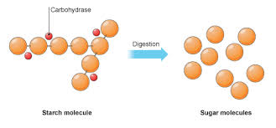
Digestion is the breakdown of large molecules into smaller, soluble molecules that can be absorbed into the body.

The majority of absorption occurs in the small intestine but large molecules cannot pass through the walls into the blood, to end up where they are needed in the body so the need to get broken down first by digestion.
Large molecules in food must be broken down into smaller ones so that they can diffuse through the gut wall & into your blood. To do this digestive enzymes are needed and an enzyme is able to bind to only specific molecules (known as the substrate). They have an area called the active site when the substrate(s) bind. This has a very specific shape.
+
↔
↔
+

A model people use to explain this is the idea of a lock and key. The enzyme is the ‘lock’ and the substrate is the ‘key’. enzymes work In the same way that a key fits into a lock, so a substrate is thought to fit into an enzyme’s active site. The enzyme is the lock, and the substrate is the key.
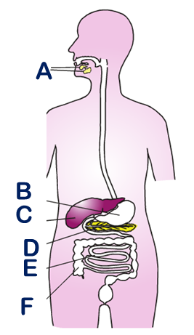
Task 1 - Label the parts of the digestive system without looking back on previous work!

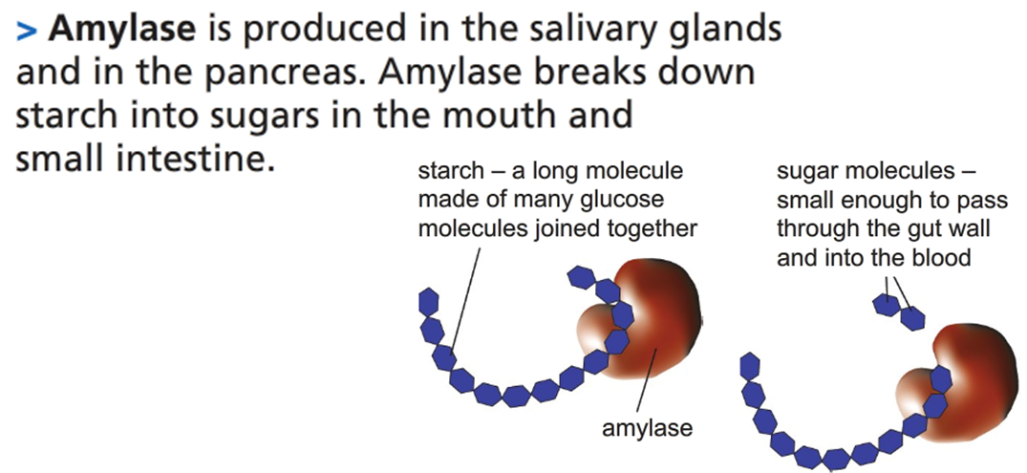

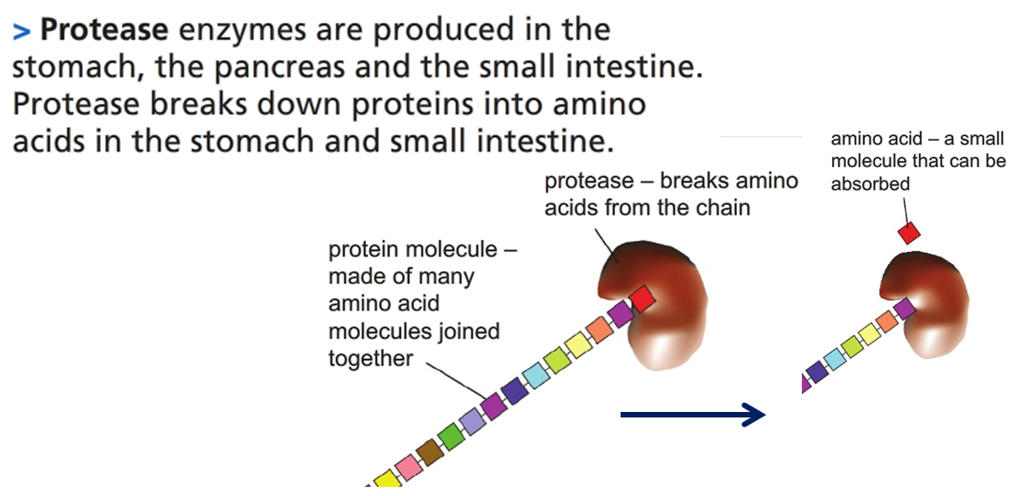

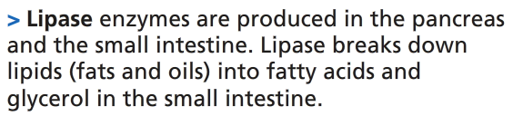
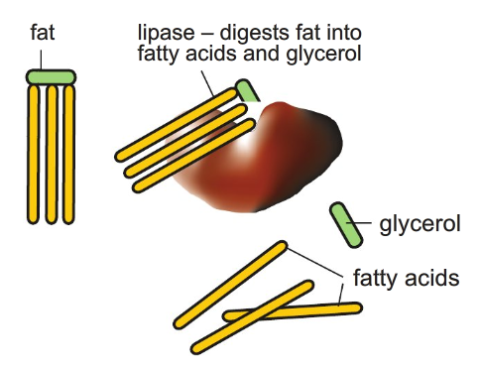

Enzyme | Where it is made | Where it works | What it does

SLOP Questions
- What needs to happen to food molecules in order to pass into your blood?
_______________________________________________________________________________________________
_______________________________________________________________________________________________
_______________________________________________________________________________________________
- Where are digestive enzymes made? Name some specific examples of these type of organs.
_______________________________________________________________________________________________
_______________________________________________________________________________________________
_______________________________________________________________________________________________
- All enzymes are sensitive to temperature but the digestive enzymes are particularly sensitive to pH. In which part of the digestive system do enzymes prefer:
a) Acidic conditions
_______________________________________________________________________________________________
b) Alkaline conditions
_______________________________________________________________________________________________
- When you chew food it mixes with amylase in your mouth which starts to digest the starch. When the food arrives in your stomach the amylase stops working. Explain why this happens.
_______________________________________________________________________________________________
_______________________________________________________________________________________________
_______________________________________________________________________________________________
_______________________________________________________________________________________________
_______________________________________________________________________________________________
- Enzymes in digestion are very sensitive to temperature and especially pH. Using the key words listed denaturing, enzyme, pH, substrate, catalysed optimum, active site. Explain what happens to an enzyme if it is subjected to a pH above its optimum.
_______________________________________________________________________________________________
_______________________________________________________________________________________________
_______________________________________________________________________________________________
_______________________________________________________________________________________________
_______________________________________________________________________________________________
_______________________________________________________________________________________________

