B3 Infection and response: Mastery booklet
Communicable diseases are ones that can be spread between individuals. Some examples include tuberculosis, measles and flu. Communicable diseases can be caused by pathogens which are disease causing micro-organisms. Pathogens can be bacteria, viruses and fungi. Non –communicable diseases cannot be transmitted between individuals. Some examples include arthritis and heart attacks. Both communicable and non-communicable diseases cause ill health. Other factors like diet, stress and age can affect chances of being ill.
Part 1- Pathogens and disease
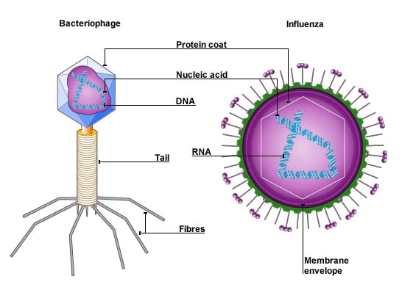
Pathogens are micro-organisms that cause disease. There can be many types of pathogens including bacteria, viruses, protists or fungi. The diseases caused by pathogens are known as communicable diseases as they can be spread between individuals. Pathogens can be spread in different ways. Some pathogens can be spread through the air by coughing, sneezing and even talking (droplet infection). Examples include flu (caused by a virus) and tuberculosis (caused by a bacteria). Some pathogens are spread by direct contact. For example, sexually transmitted diseases such as gonorrhoea (caused by a bacteria) and HIV/AIDS (caused by a virus). Other pathogens can be spread through water, for example, cholera or salmonella. These diseases often cause diarrhoea. Diseases often spread quicker through crowded city centres.
The two main types of pathogens that cause disease are bacteria and viruses. Bacterial pathogens are prokaryotic cells that cause disease by releasing toxins that make you feel ill. Once inside our body bacteria cells divide by binary fission. Viruses invade our cells, they then reproduce inside the cells (not by binary fission), and continue to do so until the cell bursts. This can create direct symptoms or you might experience symptoms as a result of your immune system fighting off the infection. Because they are unable to reproduce on their own viruses are not living things. They are also incredibly small, about 100 times smaller than bacteria.
- What is a pathogen?
- Clive says “Bacteria and Viruses are both prokaryotic cells” explain the common mistake he has made
- List the different types of pathogens
- State two diseases caused by bacteria
- State two diseases caused by viruses
- What are three ways pathogens can be spread
- What do bacteria release to make us ill?
- How do bacteria divide?
- Label the prokaryotic cell

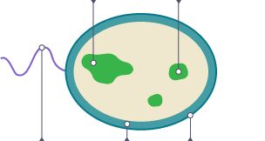

- How do viruses make us ill?
- Suggest the ways that pathogens could enter your body
- Suggest why pathogens/diseases that spread through water often cause diarrhoea
- Suggest ways that the spread of diseases in air droplets could be prevented
- Suggest why diseases spread faster in city centres
- Complete the venn diagram to compare the similarities of bacteria and virus pathogens

- Compare bacterial and virus pathogens use the sentence starters below to help
Both viruses and bacteria are examples of…
An example of a viral disease is…. Whereas….
Bacteria make us feel …. Similarly…..
Bacteria work by releasing…. Contrastingly….
- Describe how diseases can be spread
- Compare bacterial and viral diseases making sure to include examples
- Suggest what safety measures you could incorporate around the school to prevent the spread of disease
- The school wants to bring in a rule where students must shake a teachers hand before entering the classroom. Explain why this is a bad idea
- This is an evaluate question. This means you must tell me both advantages and disadvantages for each drug and then provide a logical conclusion of which one is best

Read the information about cholesterol and ways of treating high cholesterol levels.

Diet and inherited factors affect the level of cholesterol in a person's blood.
Too much cholesterol may cause deposits of fat to build up in blood vessels and reduce the flow of blood. This may cause the person to have a heart attack.
Some drugs can lower the amount of cholesterol in the blood.

The body needs cholesterol. Cells use cholesterol to make new cell membranes and some hormones. The liver makes cholesterol for the body.

Some drugs can help people with high cholesterol levels.

Statins block the enzyme in the liver that is used to produce cholesterol.
People will normally have to take statins for the rest of their lives. Statins can lead to muscle damage and kidney problems. Using some statins for a long time has caused high numbers of deaths. Cholesterol blockers reduce the absorption of cholesterol from the intestine into the blood. Cholesterol blockers can sometimes cause problems if the person is using other drugs. Evaluate the use of the two types of drug for a person with high cholesterol levels.

Part 2- Disease

Pathogens that cause disease come in 4 main categories: virus, bacteria, protists and fungi.

Viral diseases

Measles is a viral disease showing symptoms of fever and a red skin rash. Measles is a serious illness that can be fatal if complications arise. For this reason, most young children are vaccinated against measles. The measles virus is spread by inhalation of droplets from sneezes and coughs.

HIV initially causes a flu-like illness. Unless successfully controlled with antiretroviral drugs the virus attacks the body’s immune cells. Late stage HIV infection, or AIDS, occurs when the body's immune system becomes so badly damaged it can no longer deal with other infections or cancers. HIV is spread by sexual contact or exchange of body fluids such as blood which occurs when drug users share needles.

Tobacco mosaic virus (TMV) is a widespread plant pathogen affecting many species of plants including tomatoes. It gives a distinctive ‘mosaic’ pattern of discolouration on the leaves which affects the growth of the plant due to lack of photosynthesis.

Bacterial diseases

Salmonella food poisoning is spread by bacteria ingested in food, or on food prepared in unhygienic conditions. In the UK, poultry are vaccinated against salmonella to control the spread. Fever, abdominal cramps, vomiting and diarrhoea are caused by the bacteria and the toxins they secrete.

Gonorrhoea is a sexually transmitted disease (STD) with symptoms of a thick yellow or green discharge from the vagina or penis and pain on urinating. It is caused by a bacterium and was easily treated with the antibiotic penicillin until many resistant strains appeared.

Gonorrhoea is spread by sexual contact. The spread can be controlled by treatment with antibiotics or the use of a barrier method of contraception such as a condom.

- How is measles spread?
- Name 2 symptoms of measles?
- What does the HIV attack?
- How is HIV spread?
- Is Salmonella a bacteria or virus?
- Name 2 symptoms of food poisoning.
- What is gonorrhoea?
- How can gonorrhoea be prevented and treated?

Fungal diseases

Fungi are living organisms. They are Eukaryotic organisms and include: mushrooms, toadstools, moulds and yeast. They produce spores (for reproduction) and digest organic matter. They do not photosynthesise so in some ways are more closely linked to animals than plants.

Rose black spot is a fungal disease where purple or black spots develop on leaves, which often turn yellow and drop early. It affects the growth of the plant as photosynthesis is reduced. It is spread in the environment by water or wind. Rose black spot can be treated by using fungicides and/or removing and destroying the affected leaves.

Protist diseases

Protists are microscopic and unicellular. They are Eukaryotes. The parasitic diseases that they cause can be life threatening. Malaria is an example of a disease caused by a protist. The parasite spends some of its time living inside mosquitoes and the rest inside humans. The mosquito spread the protists from one human to another. They are said to be the vector of transmission for the disease. When in the body the protist can damage the liver and the red blood cells. Malaria is widespread in tropical areas and kills 660,000 people per year. Treatment for malaria involves taking a combination of drugs and is becoming less effective. The best strategies involve preventing the spread by targeting the mosquito vectors.

This is achieved by:
- Using insecticide-impregnated insect nets to prevent human being bitten
- Using insecticides to kill mosquitoes
- Preventing the breeding of mosquitoes by removing their breeding habitats like standing water.
- Providing travellers with antimalaria drugs which kill the parasites if they get bitten
- What is the difference between eukaryotic and prokaryotic organisms
- What is a vector?
- What is the meaning of unicellular?
- What causes the spread of malaria?
- Why is the chance of getting malaria in the UK very low
- Why would leaving black spotted leaves on the ground cause the spread of rose black spot disease?
- Microorganisms can cause disease.
(a) Draw one line from each disease to the correct description.
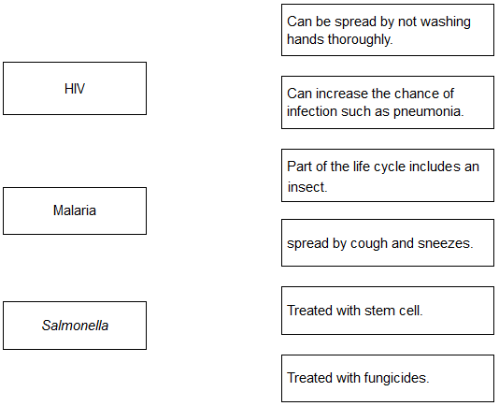
(b) Gonorrhea is a sexually transmitted disease. A bacterium causes gonorrhea.
What are the symptoms of gonorrhea?

Tick two boxes.
Headache
Pain when urinating
Rash
Vomiting
Yellow discharge

37. Scientists investigated the effect of different factors on health.
(a) People who are not active may have health problems.
The graph shows the percentage of 16-year-olds in some countries who are not active.
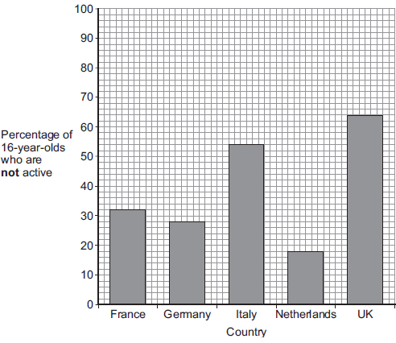
(i) What percentage of 16-year-olds in the UK are not active?
(ii) What percentage of 16-year-olds in the UK are active?
(iii) A newspaper headline states:
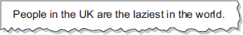
Information in Figure 1 does not support the newspaper headline.
Suggest one reason why the newspaper headline may be wrong.

(b) Doctors gave a percentage rating to the health of 16-year-olds.
100% is perfect health.
The table shows the amount of exercise 16-year-olds do and their health rating.

Amount of exercise done in minutes every week | Health rating as %
Less than 30 | 72
90 | 76
180 | 82
300 | 92
What conclusion can be made about the effect of exercise on health?
Use information from the table.
(c) Inherited factors can also affect health.
Give one health problem that may be affected by the genes someone inherits.
Draw a ring around the correct answer.

being  malnourished | having a high  cholesterol level | having a  deficiency disease
(1)
(d) White blood cells are part of the immune system.
Use the correct answer from the box to complete each sentence.

Antibiotics | antibodies | pathogens | vaccines
(i) When we are ill, white blood cells produce ………………….. to kill microorganisms.
(ii) Many strains of bacteria, including MRSA, have developed resistance to drugs called…………………………….

Part 3 - Preventing disease
As mentioned in part 1 pathogens can be spread by droplet infection, direct contact and contaminated water or food. When trying to prevent infection most of the simple strategies involve preventing these opportunities. Ignaz Semmelweis was a doctor in mid 18th century. At this time many woman died after childbirth due to something known as childbed fever. Semmelweis noticed that many doctors went straight from dissecting dead bodies to delivering a baby. Semmelweis insisted that all doctors wash their hands before delivering babies. Other discoveries include Louis Pasteur’s discovery that microorganisms cause disease. Joseph lister developed antiseptic chemicals. An easy way to prevent spread of disease is through good hygiene. Handwashing, coughing or sneezing into tissues, keeping raw meat separate from uncooked food. Isolating or quarantining those who have been infected prevents the spread. Some diseases can be transmitted by vectors. For example, malaria and dengue fever and transmitted by mosquitoes. Aphids can act as vectors as well. Destroying these vectors can prevent the spread of disease. Ways to control mosquito populations include mosquito nets, release of sterile males, and removal of standing/still water which is where young mosquitoes grow.

- Give 2 examples of how a disease is spread by droplet infection
- How can we prevent the spread of sexually transmitted infections?
- Why did Semmelweis’ suggestion of washing between patients prevent the spread of disease?
- What precautions do nurses take to prevent the spread of infections at hospitals?
- What do antiseptic chemicals do?
- What are communicable diseases?
- What is a pathogen?
- Name four microorganisms that can be pathogens (give the broad group names, rather than specific examples).
- What are symptoms?
- What chemicals can pathogens produce that cause disease symptoms?
- Where in organisms do viruses reproduce?
- How does this cause symptoms?
- State three general ways that pathogens can be spread from animal to animal (including humans).
- Describe five general methods that humans can adopt to reduce the spread of pathogens.
- State how pathogens can spread from plant to plant.

Human defences

Humans live in a world surrounded by potential pathogens. Like all other organisms we have evolved several defence systems to prevent us from getting ill.

Non-specific defence systems: these are working all the time to prevent us from pathogens.
- Skin: Provides a protective barrier that prevents pathogens entering the body
- Nose: Contains tiny hairs that trap pathogens
- Trachea and bronchi: Contain ciliated epithelial cells which move mucus up to the nose. The mucus traps pathogens.
- Stomach: Contains acid. The acid destroys pathogens that are eaten
Specific defence systems: these are the immune system and they are aimed at destroying invaders
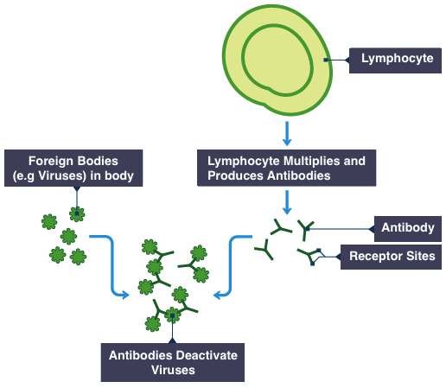
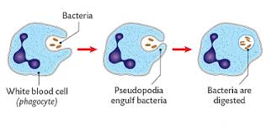
- Phagocytosis: White blood cells ingest (take in) pathogens, digesting them with enzymes so they cannot make you ill. Once the phagocytes have ingested as many pathogens as possible they die. Their dead cells form around a cut as puss
- Antibody production: While blood cells called lymphocytes produce antibodies. These target specific pathogens and stick to specific molecules on their surface called antigens. This then prevents them spreading and targets them for destruction by the immune system. Antibodies are specific to a particular pathogen and can be rapidly made again should re-infection happen.

- Antitoxin production: White blood cells can also produce antitoxins. These bind to the toxins made by bacteria and prevent them hurting your cells. 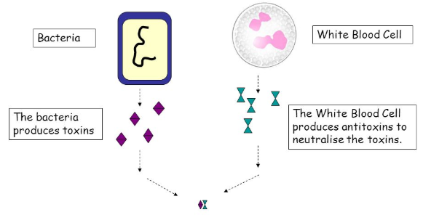
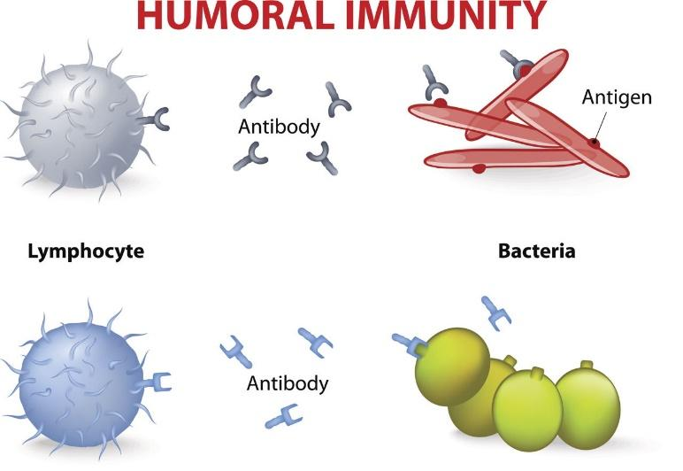
Once some of the lymphocytes have began producing antibodies and antitoxins they stay primed as memory cells. This means they can respond quickly if they are introduced to the same pathogen again. The immune system is able to adapt over time and build up a ‘memory’ of past infections. This means that over time you become more resistant to pathogens.

- What is a pathogen?
- List the non-specific defence systems the body has
- What three ways can white blood cells protect us from invading pathogens?
- Why is a virus not alive?
- What property of the stomach helps to stop food poisoning?
- Why are bacteria prokaryotic cells, but fungi are are eukaryotic cells?
- Hugh says “I’ve already had chicken pox so I can’t get it again.” Is Hugh right or wrong? Give a reason
- A child falls over in the mud and cuts their knee. After a few days yellow puss has formed around the cut and it is sore to touch. Explain how the cut became infected.
Keywords: skin, pathogen, white blood cell, ingest, phagocytosis, puss, infection
- What actions should the child’s mother have taken to prevent the cut getting infected?
- Name three specific viral diseases.
- Which virus causes fever and a red rash in humans?
- How is the spread of this virus reduced?
- How is this virus spread?
- Apart from vaccination, what other methods would be effective in reducing the spread of this virus?
- Which viral disease causes flu-like symptoms and weakens the immune cells?
- What type of cells are ‘immune cells’?
- What treatment is used to control the development of the infection?

- What condition occurs if treatment is not successful?
- Describe two ways in which the virus spread.
- What precautions can be taken to reduce the spread of the virus?
- What other diseases become more likely with a weakened immune system?
- Which virus causes discoloration of plant leaves?
- What is the main function of plant leaves?

- Which sub-cellular structure is important for this?
- How do the symptoms of this virus result in reduced plant growth?

- How is the virus spread?
- What can be done to reduce spread of the virus?
- The common cold is caused by a virus. State three symptoms of the common cold.
- How could spread of virus that causes a cold be reduced?
- Name two specific bacterial pathogens
- Which of these bacterial pathogen causes food poisoning?
- What are the main symptoms of food poisoning?
- What causes these symptoms?
- What are the most likely ways of people becoming infected with this disease?
- Which food animals was a common cause of infection?
- How has the spread of disease from this animal been reduced?
- State two precautions that could be taken to reduce spread from person to person.
- Which bacterial disease is an STD?
- What is a STD?
- What are the symptoms of this disease?
- How is infection in people treated?
- How can disease spread be prevented or reduced?
- State three sub-cellular structures you would expect both of these bacteria to have.
- State one sub-cellular structure that you would also find in an animal cell.
- Name a disease caused by a fungus
- What are the symptoms of this disease?
- How do these symptoms affect the growth of the plant?
- How is the disease spread?
- State two ways that disease spread be reduced?
- Fungi are eukaryotic. State two ways that the cell of a fungal pathogen would be different to that of a prokaryotic disease.
- Name a disease that is caused by protists.
- What are the symptoms of this disease?
- In terms of disease spread, what is a vector?
- Which vector is responsible for spreading this protest?
- How is the spread of this disease reduced?
- Sleeping sickness is a disease is caused by protists called Trypanosoma. These protists are spread by biting insects. State two methods that could reduce the spread of this disease?
- Giardia are protists that cause the disease Giardiasis, which has the symptoms of diarrhea and abdominal pain. How do you think this protest is spread?
- What precautions would you take to reduce spread?

Part 4 - Vaccination
A vaccine is an injection of a dead/inactivated form of a pathogen which means it can’t make us ill. This mean when injected into our bodies it stimulates our white blood cells to form antibodies. The antibodies then bind to the vaccine and destroy it. Some of these white blood cells become memory cells. As previously mentioned these memory cells remember how to make the antibodies required to destroy a particular pathogen. If the patient is infected by that pathogen in the future the memory cells rapidly make lots of antibodies before the pathogen can make the patient ill. This process is so rapid the person will not even be aware of it happening! The most well know vaccine is the MMR which protects us from Measles, Mumps and Rubella (german measles)
Not everyone can be vaccinated, notably the elderly and those with immune system deficiencies. In order to protect them a system known as herd immunity is used. This involves vaccinating the majority of the population. This prevents the spread of diseases as there are not enough hosts to carry the disease to the vulnerable people. Recently some parents have been deciding against vaccinating their children. There is no evidence to suggest this is a good decision. This has caused a large jump in the number of deaths from diseases that were previously under control, like measles.

- What is an antigen
- What is an antibody?
- What cells produce antibodies?
- What is the benefit of memory cells?
- What happens the second time your body meets the same pathogen?
- What is a vaccine?
- After an infection with a vaccine what do some white blood cells become?
- What is the advantage of vaccinations?
- What is herd immunity?
- Who is herd immunity of most benefit too?
- Roy is an anti vaxer. He doesn’t want to give his child the vaccine for measles. Explain why Roy is endangering both his child’s life and the life of his elderly neighbour.
- ummarise the steps of vaccination in the boxes below

- What are antigens?
- What is a pathogen?
- What are antibodies?
- Antibodies are specific to particular antigens, use the diagram to explain what this means.

- How do antibodies destroy pathogens?
- How do these white blood cells protect against future infections?
- What does a vaccine do?
- Why is it useful to vaccinate large proportions of population?
- What is in a vaccine?
- What makes vaccines safe to take?
- How do vaccines activate white blood cells?
- What happens the white blood cells once they have been activated?
- How does this prevent future infection?

- The MMR vaccine is used to protect against measles.

(a) Apart from measles, which two other diseases does the MMR vaccine protect against?

(b) Read the information.

Measles is a dangerous disease caused by a virus.
Normally, MMR vaccinations are given at 1 year old and again at 4 years old.
Each vaccination is 90% effective in protecting against the measles virus.
In April 2013, there were 630 cases of measles in children aged 4 and over in a small area of the UK. Of these cases, 504 children had not been vaccinated against MMR at all and only a few had been given a second vaccination.

(i) Calculate the percentage of the children who caught measles in April 2013 who had not been vaccinated against MMR.

(ii) Suggest one advantage to the population as a whole of children having the second MMR vaccination.

(c) (i) What does a vaccine contain?

(ii) Explain how a vaccination prevents infection.

- Vaccination can protect us from the diseases pathogens cause.

a) One type of virus causes measles. A doctor vaccinates a child against measles.

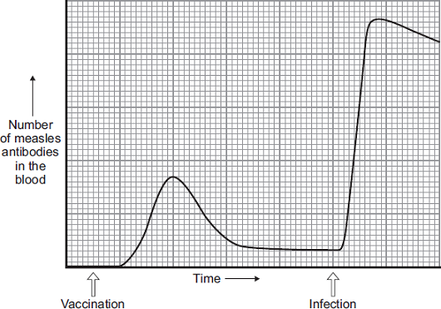
What does the doctor inject into the child to make the child immune to measles?

b) A few weeks after the vaccination, the child becomes infected with measles viruses from another person.

The graph shows the number of measles antibodies in the child’s blood from before the vaccination until after the infection.

More measles antibodies are produced after the infection than after the vaccination.

Describe other differences in antibody production after infection compared with after vaccination.

c) Vaccination against the measles virus will not protect the child against the rubella virus. Why?

d) What is the advantage of vaccinating a large proportion of the population against measles?

Part 5 – Antibiotics and Painkillers
Some medicines can be used to treat the pathogen but others can be used to relieve the symptoms. Aspirin and paracetamol are painkillers that can be used to relieve pain but do not combat the pathogen itself. Conversely, drugs like amoxicillin and penicillin are examples of antibiotics that can be used to cure bacterial diseases. Antiseptics and disinfectants can be used to kill bacteria outside the body but are too dangerous to be used inside the body as they would also kill us.
Antibiotics work by killing the bacteria that make us ill. There are different ways of taking antibiotics and in severe cases can be injected directly into the blood. Specific antibiotics only work on specific bacteria. However, antibiotics cannot completely eradicate disease because not all diseases are caused by bacteria. For example antibiotics cannot be used to treat diseases caused by viruses. This is because viruses invade our cells and antibiotics don’t harm human cells. The second reason that antibiotics cannot completely eradicate disease is the evolution of antibiotic resistant bacteria. Bacteria evolve antibiotic resistance at an alarming rate. This is because as prokaryotes, they contain DNA plasmids which can be quickly transferred between bacteria.
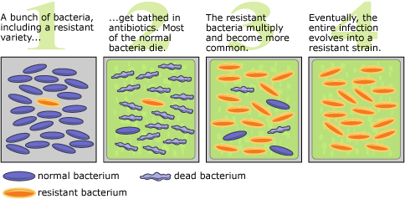
- Give two examples of painkillers
- Give how they painkillers differ from antibiotics
- What type of infections/diseases can antibiotics be used to treat?
- What are the two reasons why antibiotics cannot completely eradicate diseases?
- Why can’t viruses be killed by antibiotics?
- What is antibiotic resistance?
- What was the first antibiotic discovered?
- What happens to antibiotic resistant bacteria when they are treated with an antibiotic
- What is a difference between antiseptics and antibiotics
- The table below shows the number of people in the UK diagnosed with gonorrhoea in different years.
Number of people diagnosed
with gonorrhoea in thousands
Year | Female | Male
2005 | 5.0 | 12.5
2007 | 5.0 | 12.5
2009 | 5.5 | 12.0
2011 | 6.0 | 14.0
2013 | 7.5 | 22.0

Use the data in the table to complete the graph below.

The numbers for males have already been plotted.

Only some of the numbers for females have been plotted.

(d) Describe the patterns in the numbers of males and females with gonorrhoea from 2005 to 2013. Use the data in the graph.

(e) Gonorrhoea is treated with an antibiotic. HIV is another sexually transmitted disease. Explain why prescribing an antibiotic will not cure HIV.
- Pathogens are microorganisms that cause infectious diseases.

(a) The graph shows the percentage of children under 5 years old who died from infectious diseases, in the UK, in four different years.

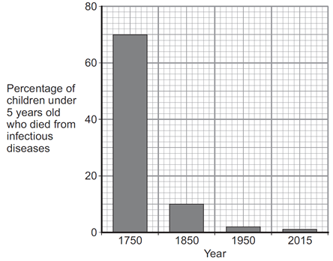

(i) Between 1750 and 1850 vaccinations were also developed. What is in a vaccine?

(ii) The advances in medicine had an effect on death rate. Describe the effect these advances had between 1750 and 1850. To gain full marks you should include data from the graph above.

- Some diseases can be cured by using antibiotics or prevented by vaccination.

(a) (i) Explain fully why antibiotics cannot be used to cure viral diseases.

(ii) There has been a large increase in the populations of many antibiotic-resistant strains of bacteria in recent years. Explain why.

- What are antibiotics?
- Name an antibiotic
- How do antibiotics work against bacteria?
- Which specific named pathogens are antibiotics effective against?
- Which pathogens are antibiotics not effective against?
- How do these pathogens reproduce?
- Which sub-cellular structure in human cells would make the virus proteins?
- Why is it difficult to kill these pathogens?
- What are painkillers?
- What effect do painkillers have on pathogens?
- Why can’t measles be treated with antibiotics?
- How has the use of antibiotics helped?
- What is antibiotic resistance?
- What are the implications of antibiotic resistance spreading?
- What can be done to reduce the spread of antibiotic resistance?
- Which form of DNA in prokaryotic cells increases the spread of antibiotic resistance?

Part 6 – Discovering drugs
There are a number of drugs in use today that were isolated from plants. Digitalis is extracted from foxglove and is used to treat heart problems. Aspirin (a painkiller) was originally extracted from the bark of willow trees. However as technology progressed acetyl salicyclic acid was synthesised in a lab. The advantage of acetyl salicyclic acid over aspirin from willow tree bark is that it causes less side effects, can be mass produced and has a higher purity.
After a holiday Alexander Fleming noticed that lots of his culture plates had mould growing on them. Around some of this mould there was a ring containing no bacteria. This suggested to him that the mould was releasing chemical that killed bacteria. He named this chemical penicillin but was unable to extract it for mass production. Instead Florey and Chain were the scientists that mass produced penicillin.
Today most new drugs are synthesised by Pharmacist working in a lab but may still originate from a plant or microorganisms. An example of this is the Noni fruit. This fruit has been used in Costa Rica for generations and recent research has shown it has antibiotic properties.
When a new drug is discovered it has to undergo extensive testing before it is allowed to be used on humans.
The aims of drug testing at to check:
- Toxicity: Will it kill humans?
- Efficacy: Will it work?
- Dosage: How much will you need to take?

Drug trails break into 2 main sections
Preclinical trials: The drug is tested on isolated cells and tissues to check it is not toxic. It is then checked on animals. This checks again for toxicity and also efficacy.
Clinical trials: The drug is tested on healthy volunteers in a very low dose to confirm the safety. Then the drug is given to volunteers suffering from the disease to determine the exact dose needed.
Clinical trials are double blind trials. This means that some of the volunteers are given the real drug and others are given a placebo. A placebo is a fake medicine. This way, scientists can be sure that it is the actual drug making people better and not just the thought of taking medicine.
After the clinical trials are completed they are verified by peer review. Other scientists scrutinise the results and repeat some of the trials to confirm the results.
Only when all steps have been passed will the drug be allowed to be prescribed to the public.
When a trail is not conducted properly the consequences can be devastating. In the 1950’s a drug called Thalidomide was given to pregnant women as a cure for morning sickness. It had never been tested on pregnant animals during trials. The women gave birth to babies with severe limb deformations.
- What drug is extracted from foxglove?
- What is digitalis used to treat?
- Where was aspirin originally extracted from?
- What improved version of aspirin was created?
- What was the advantage of this drug?
- What scientist discovered penicillin?
- What scientists mass produced penicillin?
- What observation did Fleming make on his return after his holiday?
- Who discovered penicillin?
- What is the source of most new drugs?
- What are new drugs tested for?
- What things are drugs tested on before human trials begin?
- Why must new drugs be trialled on people?
- How do human trials begin?
- What is being tested for at this stage?
- Why is it possible to test on volunteers at this stage?
- What is the drug tested for in the second phase of human trials?
- Why must patients with the disease be tested during later stages?
- What is a placebo?
- What is a double-blind trial?
- What do double-blind trials reduce the effects of?
- What is peer-review?
- Why is it important that drug trials are peer-reviewed?
- Food poisoning can be caused by eating food that is contaminated with Salmonella bacteria.
- Give one difference between a bacterial cell and an animal cell.
The table shows the number of confirmed cases of salmonella food poisoning in the UK. It is estimated that in the UK, for every confirmed case of salmonella poisoning there are another 3 unconfirmed cases.
- Estimate the total probability of suffering from salmonella food poisoning in 2015.
- Describe the trend in the number of confirmed cases of salmonella food poisoning between 2006 and 2014.
- Suggest two reasons for the trend in the data between 2006 and 2014.
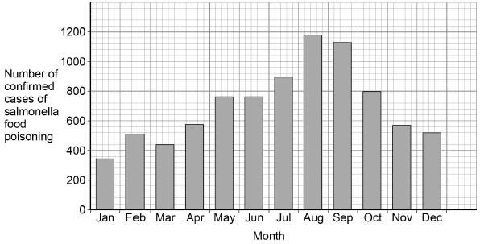
The graph shows the number of confirmed cases of salmonella food poisoning in the UK during one year.
- Suggest one reason for the high number of cases of salmonella food poisoning in the summer.

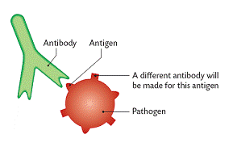
Part 7 – Monoclonal antibodies (Biology only)
Mono means ‘one’ so monoclonal means ‘cloned from one’
Monoclonal antibodies are antibodies that all stick to the exact same antigen. In a normal immune response there will be thousands of different antibodies that attack different antigens on the same pathogen.
Monoclonal antibodies are produced from a single clone of cells. The antibodies are specific to one binding site on one protein antigen and so are able to target a specific chemical or specific cells in the body. They are produced by stimulating mouse lymphocytes to make a particular antibody. The lymphocytes are combined with a particular kind of tumour cell to make a cell called a hybridoma cell. The hybridoma cell can both divide and make the antibody. Single hybridoma cells are cloned to produce many identical cells that all produce the same antibody. A large amount of the antibody can be collected and purified.
- Complete the diagram by adding the missing words. Use the text above to help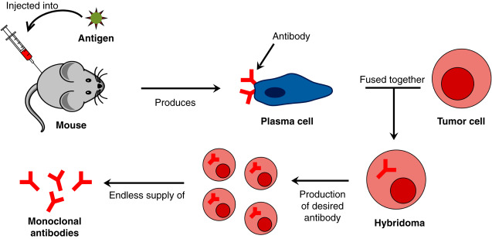
Uses of monoclonal antibodies include:
- for diagnosis such as in pregnancy tests
- in laboratories to measure the levels of hormones and other chemicals in blood, or to detect pathogens
- in research to locate or identify specific molecules in a cell or tissue by binding to them with a fluorescent dye
- to treat some diseases: for cancer the monoclonal antibody can be bound to a radioactive substance, a toxic drug or a chemical which stops cells growing and dividing. It delivers the substance to the cancer cells without harming other cells in the body

- What is an antigen?
- What is a clone?
- What are the three ways lymphocytes fight pathogens?
- Why is a tumour cell used to form a hybridoma?
- Why are monoclonal antibodies all the same?
- Erica says “monoclonal antibodies are used to fight infection” Is she correct? Give a reason.
- Why is penicillin not prescribed for a common cold?
- Will taking paracetamol speed up recovery from tonsillitis?
- Name the identical structures in all the nuclei of the hybridoma
- What type of reproduction is occurring when the hybridoma divides?
- A virus called RSV causes severe respiratory disease.
- Suggest two precautions that a person with RSV could take to reduce the spread of the virus to other people.
- One treatment for RSV uses monoclonal antibodies which can be injected into the patient. Scientists can produce monoclonal antibodies using mice. The first step is to inject the virus into a mouse. Describe the remaining steps in the procedure to produce monoclonal antibodies.
- Describe how injecting a monoclonal antibody for RSV helps to treat a patient suffering with the disease.
- A trial was carried out to assess the effectiveness of using monoclonal antibodies to treat patients with RSV. Some patients were given a placebo. Why were some patients given a placebo?

A number of patients had to be admitted to hospital as they became so ill with RSV.

The results are shown in the table below.

Treatment received by patient | % of patients within each group admitted to hospital with RSV
Group A: Monoclonal antibody for RSV | 4.8
Group B: Placebo | 10.4

The trial involved 1 500 patients.

• Half of the patients (group A) were given the monoclonal antibodies.

• Half of the patients (group B) were given the placebo.
- Calculate the total number of patients admitted to hospital with RSV during the trial.
- Evaluate how well the data in the table above supports the conclusion:

‘monoclonal antibodies are more effective at treating RSV than a placebo’.

Part 8 – Plant diseases (Biology only HT)
Plants get ill just like animals. We have already seen examples of tobacco mosaic virus and rose black spot. Aphids feeding can also introduce various pathogens into the phloem which can travel around the plant.
Symptoms of plant diseases are:

- stunted growth
- spots on leaves
- areas of decay (rot)
- growths
- malformed stems or leaves
- discolouration
- the presence of pests.

Due to the variety of species of plants the average person might have in their garden we often have to look up symptoms in a book or online. If we are concerned it is an aggressive pathogen then we might buy a testing kit, which uses monoclonal antibodies to detect a specific pathogen, or send it to a lab for testing. Preventing the spread of infections through crops is vital to ensure we have enough food to eat.
Mineral deficiencies can also present symptoms similar to those above a reduce crop yields. If a plant is lacking in nitrates it will not be able to make enough protein so its growth will be stunted. If a plant is lacking magnesium it will not be able to make enough chlorophyll. This will turn the leaves yellow (called chlorosis) and reduce the rate of photosynthesis. This therefore also reduces plant growth as there is not enough glucose for respiration.
- Name two plant diseases
- Why does an aphid puncture the phloem?
- Give 4 symptoms of possible plant disease.
- What is clorosis and what is it caused by
- Why does a farmer ensure his fields are rich in magnesium?
- Rob says “Plants need lots of nitrates so they can eat more protein for growth and repair” He is wrong. Write the correct sentence in your book.
- What should a gardener do to rose leaves infected with rose black spot to prevent the infection spreading?
- Dutch elm disease is a fungal infection spread by a beetle vector. It has destroyed 25 million elm trees in the UK alone. Suggest 2 different ways we could prevent the spread of dutch elm disease.
- Plants can be infected by fungi, viruses and insects. Aphids are small insects that carry pathogens. The diagram below shows an aphid feeding from a plant stem.

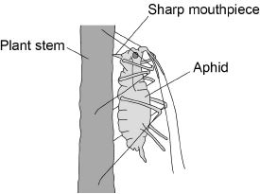
(a) An aphid feeds by inserting its sharp mouthpiece into the stem of a plant.

Give the reason why the mouthpiece of an aphid contains a high concentration of dissolved sugars after feeding.

(b) Plants infected with aphids may show symptoms of magnesium deficiency.

Magnesium deficiency symptoms include:

• yellow leaves

• stunted growth.

Explain how a deficiency of magnesium could cause these symptoms.

(c) A farmer thinks a potato crop is infected with potato virus Y (PVY).

The farmer obtains a monoclonal antibody test kit for PVY.

To make the monoclonal antibodies a scientist first isolates the PVY protein from the virus.

Describe how the scientist would use the protein to produce the PVY monoclonal antibody.
- Tobacco mosaic virus (TMV) is a disease affecting plants.

The diagram below shows a leaf infected with TMV.

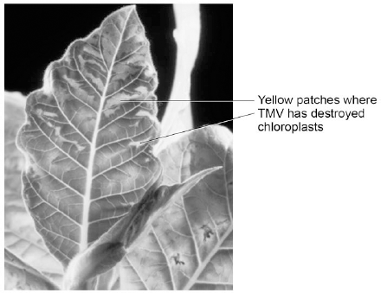

© Nigel Cattlin/Visuals Unlimited/Getty Images

(a) All tools should be washed in disinfectant after using them on plants infected with TMV. Suggest why.

(b) Scientists produced a single plant that contained a TMV-resistant gene.

Suggest how scientists can use this plant to produce many plants with the TMV-resistant gene.

(c) Some plants produce fruits which contain glucose.

Describe how you would test for the presence of glucose in fruit.

(d) TMV can cause plants to produce less chlorophyll. This causes leaf discoloration. Explain why plants with TMV have stunted growth.
- Nitrate fertilisers are important in agriculture. They help to increase crop yields and so make food cheaper to buy. Some of the nitrate fertilisers run off into rivers and get into drinking water. The problem is that the nitrates can react with iron in our blood. This reduces the blood’s ability to carry oxygen. If the amount of nitrate in drinking water is too high, it can cause ‘blue baby syndrome’, in which babies look blue due to lack of oxygen.

The table shows the amount of nitrate fertilisers used and the crop yield.

Nitrate fertilisers in kilograms per hectare of land | 0 | 150 | 250
Crop yield in tonnes per hectare of land | 5 | 8 | 7

Use the information above to suggest what should be done, by farmers and government, to prevent ‘blue baby syndrome’. Explain the reasons for your suggestions.
- Changing the conditions in which plants grow affects how fast they grow.

The diagram shows a propagator in which scientists can control temperature, light intensity and carbon dioxide concentration.

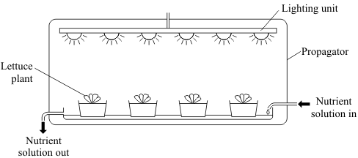

The graph shows the effects of changing the temperature, light intensity and carbon dioxide concentration on the growth of lettuce plants.
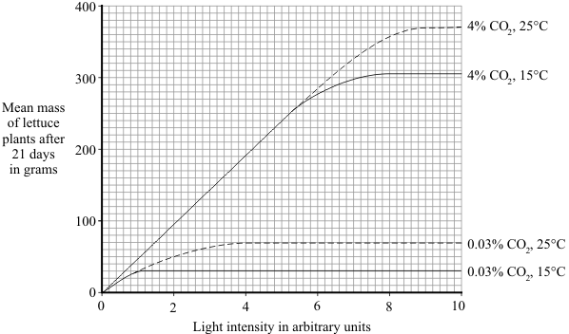

(a) Describe and explain the effect of increasing light intensity on the mean mass of lettuce plants at 4% carbon dioxide and 15 °C.

(b) Growers wish to make maximum profits from their lettuces.

What do they need to consider before making decisions about the growing conditions for their lettuces?

(c) The nutrient solution contains nitrate ions and magnesium ions.

Complete the table to show the functions of these ions in plants and their deficiency symptoms.
Ion | Function in plants | Deficiency symptoms
Nitrate
Magnesium

